Total Maximum Daily Load for Escherichia coli (E. coli) in the Fremont River Watershed

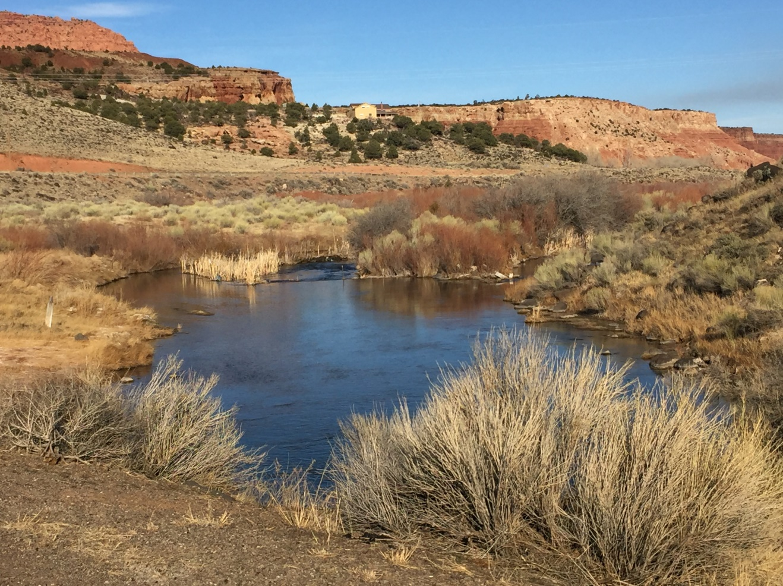

Prepared by
Utah Department of Environmental Quality
Division of Water Quality

Amy Dickey, Project Manager
Jodi Gardberg, Project Supervisor

Utah Department of Environmental Quality
Division of Water Quality
Fremont River TMDL

Waterbody ID/Assessment Unit | Fremont River 2:  UT14070003-005
Location | Fremont River and tributaries from Bicknell to Mill Meadow Reservoir near USFS boundary
Pollutants of Concern | Escherichia coli (E. coli)
Impaired Beneficial Uses | Class 2A: Frequent Primary Contact Recreation  (Not yet 303(d) listed but 2 monitoring locations indicate impairment. Will be included on the 2020 list.)
Current Loading  Loading Capacity (TMDL)  Load Reduction | 126 X10⁹ MPN/day  15.4 X 10⁹ MPN/day  88%  (Calculations based on sampling location 4955330: Fremont River at Big Rocks Rd. Loading calculations are averages of recreation season months that require a reduction)
Wasteload Allocation  Load Allocation  Margin of Safety (10% of Loading Capacity) | 0 organisms/day (no point sources)  15.4 X 10⁹ MPN/day  15.4 X 10⁸ MPN/day
Defined Targets/Endpoints | 1. For recreation seasons (May 1st through October 30th) with ≥5 collection events, no more than 10% of samples shall exceed 409 MPN/100 mL.  2. For recreation seasons with ≥5 collection events, no 30-day interval geometric means shall exceed 126 MPN/100 mL.  3. For recreation seasons with ≥10 collection events, the geometric mean of all samples shall not exceed 126 MPN/100 mL.
Implementation Strategy | Stakeholders will employ a voluntary adaptive management approach to address all anthropogenic sources of E. coli loading with focus on improvements in grazing management and septic system inspection and maintenance. TMDL endpoints will be re-evaluated within 10 years.

Utah Department of Environmental Quality
Division of Water Quality
Fremont River TMDL

Waterbody ID/Assessment Unit | Fremont River 3:  UT14070003-008
Location | Fremont River and tributaries from east boundary of Capitol Reef National Park to Bicknell
Pollutants of Concern | Escherichia coli (E. coli)
Impaired Beneficial Uses | Class 2A: Frequent Primary Contact Recreation
Current Loading  Loading Capacity (TMDL)  Load Reduction | 399.7 X 10⁹ MPN/day  110.5 X 10⁹ MPN/day  72%  (Calculations based on sampling location 4954390: Fremont River at Highway 12 Crossing. Loading calculations are averages of recreation season months that require a reduction)
Wasteload Allocation  Load Allocation  Margin of Safety (10% of Loading Capacity) | 0 organisms/day (no point sources)  110.5 X 10⁹ MPN/day  110.5 X 10⁸ MPN/day
Defined Targets/Endpoints | 1. For recreation seasons (May 1st through October 30th) with ≥5 collection events, no more than 10% of samples shall exceed 409 MPN/100 mL.  2. For recreation seasons with ≥5 collection events, no 30-day interval geometric means shall exceed 126 MPN/100 mL.  3. For recreation seasons with ≥10 collection events, the geometric mean of all samples shall not exceed 126 MPN/100 mL.
Implementation Strategy | Stakeholders will employ a voluntary adaptive management approach to address all anthropogenic sources of E. coli loading with focus on improvements to failing septic systems and grazing and irrigation management. TMDL endpoints will be re-evaluated within 10 years.

EXECUTIVE SUMMARY

This Total Maximum Daily Load (TMDL) study reviews the available E. coli data for the Fremont River needed to assess and restore the recreational beneficial use of the river as defined by Utah Administrative Code R317-2-6 and the Clean Water Act (CWA). States must develop a TMDL when water quality impairments result in their listing on the CWA Section 303(d) List of Impaired Waterbodies. The Fremont River watershed was listed as impaired in the Utah 2014 Integrated Report and was a high priority for E. coli TMDL development by the Utah Division of Water Quality (DWQ) due to the large number of people that recreate in the river in and around Capitol Reef National Park. E. coli is an indicator of recent fecal contamination, and ingestion of water containing fecal pathogens poses a public health risk.

Water quality concerns in the Fremont River were first identified through routine monitoring in 2010. A follow-up study conducted by Capitol Reef National Park staff showed high E. coli concentrations in park waters (Hackbarth et al, 2018). Since then, hundreds of E. coli samples have been collected throughout the watershed by DWQ, Utah State University Extension, Capitol Reef National Park, and Utah Water Watch to better understand the temporal and spatial extent of the problem.

E. coli data have been collected at 10 sampling sites throughout the Fremont River watershed on a monthly basis through the recreation season of May through October, as well as during non-recreation season months. Exceedances of the 2A recreation water quality standards are highest during the recreation season months, specifically July and August, and are driven by livestock (74% of load) and wildlife (25% of load) grazing in close proximity to the river, as well as potentially failing septic systems (1% of load).

DWQ believes E. coli loading will be reduced and beneficial uses restored and protected with implementation of the best management practices identified in this document.

TABLE OF CONTENTS

EXECUTIVE SUMMARY 3
List of Tables 6
List of Figures 7
1.0 INTRODUCTION AND BACKGROUND 9
2.0 TMDL TARGETS 10
2.1 Total Maximum Daily Load Definition 10
2.2 Study Area Boundary 10
2.3 Impairment of the Fremont River 12
2.4 Parameter of Concern (E. coli) 15
2.5 Applicable Water Quality Standards 15
2.6 TMDL Endpoints 16
3.0 WATERSHED CHARACTERIZATION 16
3.1 Physical Features 16
3.1.1 Geology 16
3.1.2 Hydrology 17
3.1.3 Water Supply and Uses 20
3.1.4 Precipitation and Climate 22
3.2 Biological Features 23
3.2.1 Fisheries 23
3.2.2 Wildlife 24
3.3 Land Use 25
3.3.1 Land Ownership 25
3.3.2 Land Cover and Water Related and Use 27
4.0 WATER QUALITY DATA 30
4.1. Previous Bacteria Water Quality Study 30
4.2 Flow Data 31
4.3 Monitoring Results 32
4.3.1 Monitoring Location Details 40
4.4 Water Quality Analysis 52
4.5 Supplemental Monitoring Techniques 53
4.5.1Pharmaceuticals and Personal Care Products 53
5.0 TMDL 54
5.1 Calculation of Loading Capacity and Existing Load 54
5.2 Load Duration Curve 55
5.3 TMDL 61
5.4 Seasonality 61
6.0 SOURCE ASSESSMENT 67
6.1 Point Sources 68
6.2 Nonpoint Sources 69
6.2.1 Humans 70
6.2.2 Wildlife 72
6.2.3 Livestock 73
6.3 Source Assessment Summary 75
6.3.1 Bacteria Production 75
6.3.2 Source Assessment 76
6.3.3 Assumptions and Uncertainty 78
6.3.4 Transport Pathways 79
7.0 IMPLEMENTATION PLAN 79
7.1 Animal Feeding Operations 81
7.2 Grazing Management 82
7.3 Septic Systems 82
7.4 Information and Education Component 83
7.5 Implementation Cost and Technical Assistance 85
7.6 Implementation Schedule and Milestones 86
8.0 FUTURE MONITORING 89
9.0 PUBLIC INVOLVEMENT 89
REFERENCES 91
Appendix A: Utah Division of Water Quality Listing Methodology for E. coli 94
Appendix B: Bureau of Land Management Grazing Allotment Tables 98
Appendix C: SITLA Grazing Allotment Tables 103
Appendix D: US Forest Service Grazing Allotments in Fremont River Watershed 106
Appendix E: U.S Fish and Wildlife Service List of Threatened and Endangered Species for Wayne County (Source: USFWS website August 2019) 108
Appendix F: Measured and Modeled Flow Data Used for Loading Calculations 111

List of Tables
Table 1. Designated uses for the impaired Fremont River segments from Utah R317-2-13 14
Table 2. Impaired assessment units in the Fremont River Watershed 14
Table 3. Water quality standards for Fremont River-2 and Fremont River-3 AUs 15
Table 4. Summary of stream types in Fremont River watershed 19
Table 5. Points of diversion in the Fremont River watershed 20
Table 6. Land ownership in the Fremont River watershed 24
Table 7. Dominant land use and cover throughout the Fremont River watershed 26
Table 8. E. coli summary statistics for Fremont River watershed monitoring locations. Sites listed upstream to downstream. Site IDs shown in red triggered the 303(d) listing in 2014. 31
Table 9. Percent exceedance of 2A maximum criterion (409 MPN / 100mL) for Fremont River watershed monitoring locations. 32
Table 10. Summary of monitoring location recreation season geometric means. Geometric means highlighted in red exceed the seasonal geometric mean of 126 MPN/100 mL. 34
Table 11. Relationship between LDC hydrologic regimes and potential contributing sources (Source: EPA 2017a) 51
Table 12. Loading capacity, observed loading and necessary percent reductions based on 4955330 Fremont River at Big Rocks Road monitoring site 60
Table 13. Loading capacity, observed loading and necessary percent reductions based on 4954390 Fremont River at U12 Crossing monitoring site 60
Table 14. Loading capacity, observed loading and necessary percent reductions based on 4954480 Fremont River at campground in CRNP monitoring site 60
Table 15. Loading capacity, observed loading and necessary percent reductions based on 4954770 Sulphur Creek above Fremont River at picnic area monitoring site 61
Table 16. UPDES permits in the Fremont River watershed 62
Table 17. Individual onsite wastewater treatment systems in the Fremont River TMDL area 64
Table 18. Large underground wastewater disposal systems in the Fremont River TMDL area 64
Table 19. Livestock estimates on private property. (Source: 2017 Utah Agricultural Census) 67
Table 20. Livestock estimates on public lands 68
Table 21. Bacteria production by animal 69
Table 22. Bacteria contribution by source during the recreation season 70
Table 23. Potential funding opportunities for nonpoint source projects. 78
Table 24. Implementation schedule and milestones 79

List of Figures

Figure 1. Location of the Fremont River watershed 11
Figure 2. Map of the Fremont River watershed assessment units 13
Figure 3. Geologic data in the Fremont River watershed 17
Figure 4. Stream Types in the Fremont River watershed 19
Figure 5. Points of diversion in the Fremont River watershed 21
Figure 6. Annual precipitation (inches) in the Fremont River watershed 22
Figure 7. Land Ownership in the Fremont River watershed 25
Figure 8. Dominant vegetation and land use in the Fremont River watershed 26
Figure 9. Monitoring locations from NPS E. coli study 27
Figure 10. Mean of monthly discharge (cfs) at USGS 09330000 Fremont River near Bicknell, UT 29
Figure 11. Fremont River E. coli Monitoring Locations 30
Figure 12. Image of 4955310: Spring Creek at U24 Crossing. September 2019 36
Figure 13. E. coli concentrations at 4935310 Spring Creek at U24 Crossing from 2016-2018 36
Figure 14. Image of 4955330: Fremont River at Big Rocks Road 37
Figure 15. E. coli concentrations at 4955330 Fremont River at Big Rocks Road from 2015-2018 38
Figure 16. Image of 4954380: Fremont River at Bicknell 39
Figure 17. E. coli concentrations at 4954380 Fremont River at Bicknell from 2016-2018 39
Figure 18. E. coli concentrations at 4954390 Fremont River at U12 Crossing from 2008-2018 40
Figure 19. E. coli concentrations at 4954680 Fish Creek at County Road Crossing from 2016-2018 41
Figure 20. E. coli concentrations at 4954482 Fremont River above Hatties Field in Capitol Reef National Park from 2011-2018 42
Figure 21. E. coli concentrations at 4954480 Fremont at Campground in Fruita from 2010-2018 43
Figure 22. Image of 4954480: Fremont River at Campground in Fruita. August 2019 43
Figure 23. E. coli concentrations at 4954772 Sulphur Creek at First Road Crossing above confluence with Fremont River from 2013-2018 44
Figure 24. Image of 4954772: Sulphur Creek at first road crossing above Fremont River. August 2019 45
Figure 25. E. coli concentrations at 4954770 Sulphur Creek at picnic area above Fremont River from 2012-2018 46
Figure 26. Image of 4954770: Sulphur Creek at picnic area above Fremont River. August 2019 46
Figure 27. E. coli concentrations at 4954360: Fremont River at Hickman Bridge Trailhead from 2016-2018 47
Figure 28. Calendar season load duration curve for 4955330: Fremont River at Big Rocks Road 52
Figure 29. Recreation season load duration curve for 4955330: Fremont River at Big Rocks Road 53
Figure 30. Calendar season load duration curve for 4954390: Fremont River at U12 Crossing 53
Figure 31. Recreation season load duration curve for 4954390: Fremont River at U12 Crossing 54
Figure 32. Calendar season load duration curve for 4954480: Fremont River at campground above road crossing in Fruita 54
Figure 33. Recreation season load duration curve for 4954480: Fremont River at campground above road crossing in Fruita 55
Figure 34. Calendar season load duration curve for 4954770: Sulphur Creek above Fremont River at picnic area 55
Figure 35. Recreation season load duration curve for 4954770: Sulphur Creek above Fremont River at picnic area 56
Figure 36. Monthly observed E. coli concentration summary for 4955330 Fremont River at Big Rocks Road 57
Figure 37. Image of 4954390: Fremont River at U12 Crossing 58
Figure 38. Monthly observed E. coli concentration summary for 4954480 Fremont River at Campground in CRNP 58
Figure 39. Monthly observed E. coli concentration summary for 4954770 Sulphur Creek above Fremont River at picnic area 59
Figure 40. Utah Division of Wildlife Resources Plateau Fishlake/Thousand Lake Wildlife Management Unit 66
Figure 41. Estimated bacteria contribution by source during the recreation season 71
Figure 42. Seasonal assessment against maximum criterion 85
Figure 43. 30-day assessment against geometric mean 86
Figure 44. Seasonal geometric mean assessment 87
Figure 45. Map of BLM grazing allotments in Fremont River watershed 93
Figure 46. Map of current livestock grazing AUMs on Forest Service listed by allotment 97

1.0 INTRODUCTION AND BACKGROUND
This document represents the TMDL analyses of two assessment units of the Fremont River watershed to fulfill Clean Water Act (CWA) requirements for impaired waters. A TMDL analysis determines the maximum amount of an identified pollutant (i.e., the load) that a waterbody can receive and still support its beneficial uses and meet state water quality standards. Once the pollutant loads and sources have been identified, controls are implemented to reduce those loads until the waterbody meets water quality standards. Upon completion of the TMDL analysis, the TMDL is submitted to the Utah Water Quality Board and the U.S. Environmental Protection Agency (EPA) for final approval.
The purpose of the CWA is to improve and protect the physical, chemical, and biological integrity of the nation’s waters. The CWA requires EPA or delegated authorities such as states, tribes, and territories to evaluate the quality of waters, establish beneficial uses, and define water quality criteria to protect those uses. Section 303(d) of the CWA requires that every two years, as part of the Integrated Reporting process, each state publish a list of waterbodies that fail to meet state water quality standards. This list is made available for public review and submitted to the EPA for review as well. Waterbodies placed on the 303(d) list are referred to as impaired waters. The CWA requires a TMDL analysis for 303(d) waters for each pollutant responsible for the impairment of its designated use(s).
DWQ collects biological and water quality data as part of the Integrated Report process and assesses whether the waterbody is meeting water quality standards for its designated beneficial uses. The Fremont River (Fremont River-3: UT14070003-008, Fremont River and tributaries from east boundary of Capitol Reef National Park to Bicknell) was listed as impaired on the State of Utah’s 303(d) list in 2014 for not meeting primary recreational uses due to exceedances of water quality standards for E. coli bacteria. The Fremont River segment addressed by this TMDL is part of the DWQ prioritization plan to meet EPA’s Long-Term Vision for Assessment, Restoration, and Protection under the CWA Section 303(d) Program. This report defines the TMDL and water quality targets that, when attained, will bring the river into full support of its recreational (2A) beneficial uses.

2.0 TMDL Targets

2.1 Total Maximum Daily Load Definition
The State is required to develop a TMDL to reduce pollutant levels in impaired waters subsequent to 303(d) listing. A TMDL is a calculation of the maximum amount of a pollutant that a waterbody can receive on a daily basis and still meet water quality standards. It is the sum of individual wasteload allocations (WLAs) from point sources, load allocations (LAs) from nonpoint sources and natural background levels, and includes a margin of safety (MOS), either defined implicitly or explicitly, that accounts for the uncertainty in the relationship between pollutant loads and the quality of the receiving waterbody. This sum is calculated through the following equation:

TMDL = ∑ WLAs + ∑ LAs + MOS

The TMDL process consists of the following steps:
- Review existing water quality data.
- Identify sources and causes of pollutants.
- Identify water quality goals.
- Establish the amount of pollutant that can be allowed in total.
- Allocate allowable pollutant loads to the various sources.
- Identify and implement measures to achieve and maintain water-quality standards.
- Monitor to assure that goals are met.

2.2 Study Area Boundary
The Fremont River watershed is located in south central Utah on the Wasatch Plateau (Figure 1) and drains approximately 1,980 mi². The majority of the Fremont River watershed is located in Wayne County, although small portions fall within Sevier, Piute, and Garfield counties as well. The river flows a distance of 95 miles from the headwaters to its confluence with Muddy Creek. The watershed is owned and managed by the following federal, state, and local entities:
- 41%: U.S. Bureau of Land Management
- 30%: U.S. National Forest
- 13%: National Park Service
- 11%: State Trust Land
- Five percent: private
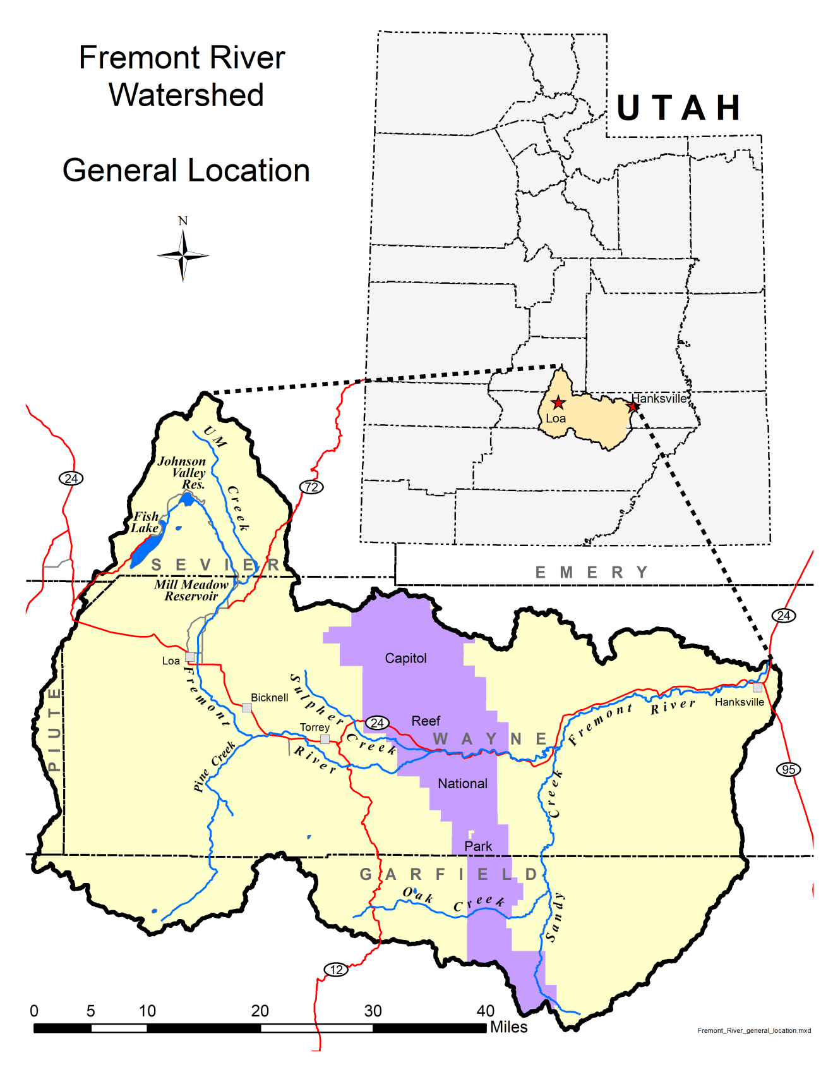

Figure 1. Location of the Fremont River watershed

2.3 Impairment of the Fremont River
Utah waters are assigned beneficial uses that delineate existing uses of the water (UAC R317-2-6). All uses have numeric criteria associated with them that must be met to ensure beneficial use support. The designated beneficial uses for the Fremont Watershed are provided in Table 1. Utah assesses surface waters of the state at the monitoring-site level then summarizes the site-level assessment up to a larger spatial scale known as an Assessment Unit.

Fremont River-3 (Fremont River and tributaries from the east boundary of Capitol Reef National Park to Bicknell) (Figure 2) is the only Fremont watershed assessment unit (AU) currently 303(d) listed for E. coli exceedances (DWQ 2016 Integrated Report). However, recent monitoring results within the upstream Fremont-2 AU (Fremont River and tributaries from Bicknell to Mill Meadow Reservoir near USFS boundary) indicate E. coli impairment, and this AU will be listed as part of the combined 2018/2020 Integrated Report. This study includes a TMDL for Fremont River-2 AU in advance of that listing, and the implementation plan includes recommended best management practices for that area. This TMDL for the Fremont River-2 AU provides interested landowners with the justification and support to receive technical and financial assistance if they want to make improvements prior to the issuance of the 2018/2020 Integrated Report.

Frequent primary contact recreational use (Class 2A) such as swimming is the beneficial use impaired by E. coli exceedances in the Fremont River. While full immersion is not common among all of the users who recreate in the river, there may be a substantial number engaged in primary contact activities, especially during the warmer summer months of the recreation season.

In addition to the E. coli impairment, Fremont River-3 is impaired for temperature and total dissolved solids (Table 2). Fremont River-2 is impaired for pH and temperature. DWQ will address these listings in the future.

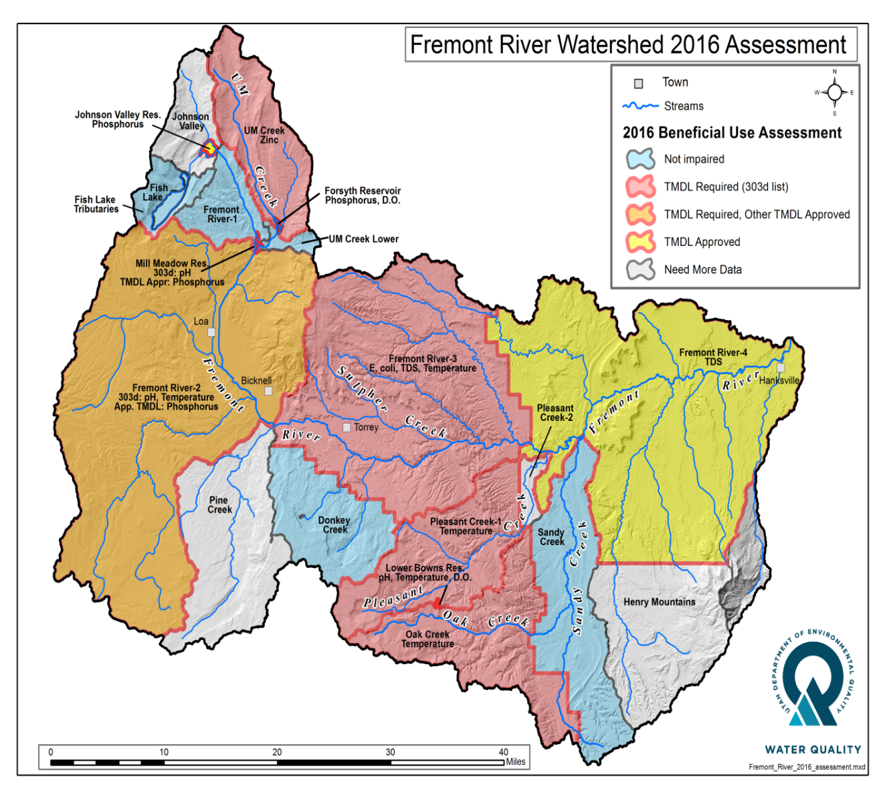

Figure 2. Map of the Fremont River watershed assessment units (AUs)

Table 1. Designated uses for the impaired Fremont River segments from Utah R317-2-13

Name | Designated Beneficial Uses
Fremont River and tributaries, through Capitol Reef National Park to headwaters | Domestic water source (1C)  Frequent primary contact recreation (2A)  Cold water fishery and other aquatic life (3A)  Agricultural uses (4)

Table 2. Impaired assessment units in the Fremont River watershed

Assessment Unit Description | Assessment Unit ID | Cause of Impairment | Impaired Beneficial Use | Year Listed
Fremont River and tributaries from Bicknell to Mill Meadow Reservoir near USFS boundary | Fremont River 2:  UT14070003-005 | pH | 1C, 2A, 3A, 4 | 2014
 |  | Temperature | 3A | 2014
Fremont River and tributaries from east boundary of Capitol Reef National Park to Bicknell | Fremont River 3:  UT14070003-008 | E. coli | 1C, 2A | 2014
 |  | Temperature | 3A | 2014
 |  | Total Dissolved Solids | 4 | 2014

2.4 Parameter of Concern (E. coli)
Routine monitoring of surface waters and assessment programs are needed to ensure the protection of public health. Surface waters are monitored as part of Utah’s bacteriological monitoring program for pathogens that originate from fecal pollution from human and animal waste. It is not feasible to monitor for all pathogens in water, but by analyzing for certain indicator organisms, it is possible to assess potential health risks. Utah samples for E. coli concentrations in surface waters using EPA guidelines (EPA, 2012).

The use of indicator organisms as a means of assessing the presence of pathogens in surface waters has been adopted by the World Health Organization and EPA (WHO, 2001). E. coli are the most abundant coliform bacteria present in human and animal intestines, numbering up to one billion organisms per gram of feces. Their presence can be primarily attributed to fecal origin, and their presence in water can be an indication of recent contamination. Common sources include failing septic systems, leaking sewer lines, grazed pastures, confined feedlots, wildlife, and dog parks (Benham, 2006). Pathogenic bacteria are washed into surface waters during rainfall or snowmelt or are deposited directly in the water. These bacteria pose a threat to human health through incidental ingestion.

2.5 Applicable Water Quality Standards
Utah’s numeric criteria for E. coli can be found in Utah Administrative Code, Standards of Quality for Waters of the State (UAC R317-2). These criteria vary based on the beneficial use assignment of the waterbody. Table 3 summarizes the E. coli standards pertaining to the 303(d) listed segment in the Fremont River-3 AU.

Table 3. Water quality standards for Fremont River-2 and Fremont River-3 AUs

Designated Use | Description | E. coli Geometric Mean  (MPN*/100 mL) | E. coli Not to Exceed (MPN*/100 mL)
2A | Frequent Primary Contact Recreation | 126 | 409
*MPN/100 mL= Most Probable Number [of colonies] per 100 milliliter of water
The E. coli numeric standard for Designated Beneficial Use Class 2A waters states that sample concentrations may not exceed 126 MPN per 100 mL as a 30-day and recreation season geometric mean, or a maximum of 409 MPN per 100 mL in more than 10% of samples collected during the recreation season. The 30-day geometric mean is based on no less than five samples collected more than 48 hours apart within 30 days.

Utah’s 2014 303(d) assessment and listing methodology can be found in Appendix A.

2.6 TMDL Endpoints
TMDL endpoints represent water quality targets. The reductions specified in the TMDL report to meet the 30-day geometric mean water quality standard for E. coli will ensure no sample will exceed the acute (maximum) E. coli water quality standard based upon the current data set. The endpoints for the Fremont River E. coli TMDL are as follows:
- For years with ≥5 collection events in any recreation season (May 1st through October 30^{th)}, no more than 10% of samples shall exceed 409 MPN/100 mL.
- For recreation seasons with ≥5 collection events, no 30-day interval geometric means shall exceed 126 MPN/100 mL.
- For recreation seasons with ≥10 collection events, the geometric mean of all samples shall not exceed 126 MPN/100 mL.

3.0 WATERSHED CHARACTERIZATION

3.1 Physical Features

3.1.1 Geology
The Fremont River flows eastward from approximately 11,000 feet in elevation from former glaciated land surfaces through a transition zone of intermediate elevations and erosional features to approximately 4,300 feet on the eastern side of the watershed. The headwaters of the watershed are covered with volcanic rock derived from lava flows, while the mid-watershed near Bicknell is characterized by Navajo sandstone, the Moenkopi formation, and the Shinarump conglomerate formation (Figure 3) (Chronic, 1990).

East of Capitol Reef National Park, in the lower watershed downstream of the TMDL study area, the geology changes again as gray hills of Mancos Shale appear around Caineville. Several of these strata are highly erodible and produce abundant sediment in the sand, silt, and clay size range. High concentrations of salts within the shale affect the quality of any water with which these sediments come in contact. Additionally, this sediment is easily mobilized during flood events and has the potential to carry with it fecal bacteria deposited on the ground or settled at the bottom of the stream.

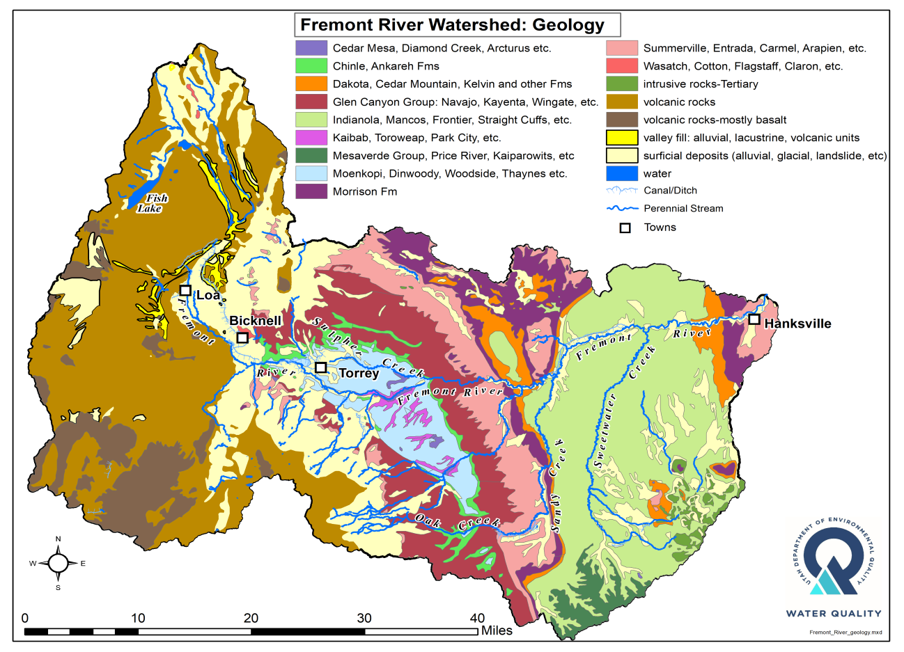

Figure 3. Geologic data in the Fremont River watershed

3.1.2 Hydrology
Flows throughout the Fremont River watershed are highly variable depending on the amount of precipitation and how much water is being diverted through irrigation canals throughout the area. Streams that originate in the high elevations near Fish Lake and Boulder Mountain are usually perennial and are diverted for agricultural use and/or storage (Table 4, Figure 4) (USDA, 2019).

The Fremont River originates from the outflow of Fish Lake at approximately 9,000 feet in elevation. The lake is fed primarily by snowmelt in the headwater streams. From Fish Lake, it flows approximately one mile through marshes and low-gradient natural stream channels into Johnson Valley Reservoir. The river continues to Mill Meadow Reservoir, where it is stored for irrigation use throughout the summer. Just below Mill Meadow Reservoir, a major withdrawal diverts surface water from the river during the irrigation season (April 1 to November 1). During the non-irrigation season (approximately November 1 to April 1), no water is released from the reservoir, though springs and seeps that arise below the dam provide some channel flow (approximately 0.5 to 3 cubic feet per second (cfs). Because all water is diverted from the channel, minimal pathogen loading is possible from the upper watershed above Mill Meadow Reservoir.

Springs and a few major tributaries contribute to the river below Mill Meadow Reservoir. These springs provide consistent discharge rates. Their flows enter the river during the non-irrigation season and are diverted to sprinkler systems during the irrigation season. Although the major tributaries drain some large watersheds, the runoff from these streams only enters the river during limited periods (days and weeks) associated with spring snowmelt (typically March/April) or during flash flooding following storms in August and September (USDA, 2019).

As the Fremont River enters the agricultural and municipal areas of Rabbit Valley from Loa to Bicknell, its flow and channel characteristics become increasingly altered. The entire flow is diverted into a canal system below Mill Meadow Reservoir. As a result, the stream channel between Mill Meadow Reservoir and its confluence with Spring Creek is most often dry. Water that arises from springs, seeps, and irrigation return flows is backed up behind "dry dams" and applied to pastures and cropland via flood or sprinkler irrigation methods. During the non-irrigation season, the river only flows where springs and seeps make it to the river. Even during this period, the river channel contains minimal flows (approximately 0.5 cfs) because water is diverted for stock watering where feasible. The flow increases incrementally as numerous springs join the river near the Bicknell Bottoms area. Three major tributaries (Big Hollow Creek, Pine Creek and Government Creek) join the Fremont River in this area.

The Fremont River becomes mostly perennial after its confluence with Spring Creek. There are numerous diversions (Figure 5) within this reach and portions of the channel are straightened. It continues through an area known as the Fremont Narrows, where flow can be near zero during dry periods. Flows increase due to recharge from springs and tributaries. Water is diverted to irrigate historic orchards in the Fruita Rural Historic District in Capitol Reef National Park. The river flows through the park for a distance of 13 miles. The river channel is heavily altered through the park as a result of the construction of Highway 24. Sulphur Creek joins the Fremont River within the park. The Fremont River flows downstream from Capitol Reef for approximately 20 miles, with Pleasant Creek and Sandy Creek as tributary streams, until it reaches a large irrigation diversion. From there, the remaining flow continues another 10 miles until the confluence with Muddy Creek near Hanksville. At that point, the two rivers combine to form the Dirty Devil River, a tributary to the Colorado River.

Table 4. Summary of stream types in the Fremont River watershed

Stream Type * | Stream Length (mi) | Percent (%)
Intermittent | 4,472 | 87.7
Perennial | 483.7 | 9.5
Artificial Path | 29.1 | 0.6
Canal/Ditch | 72.2 | 1.4
Pipeline | 4.8 | 0.1
Connector | 35.2 | 0.7
Total | 5,097 | 100

*Congress, in the Clean Water Act, explicitly directed agencies to protect “navigable waters.” The 2020 Navigable Waters Protection Rule defines those and includes perennial and intermittent tributaries to traditional waters.
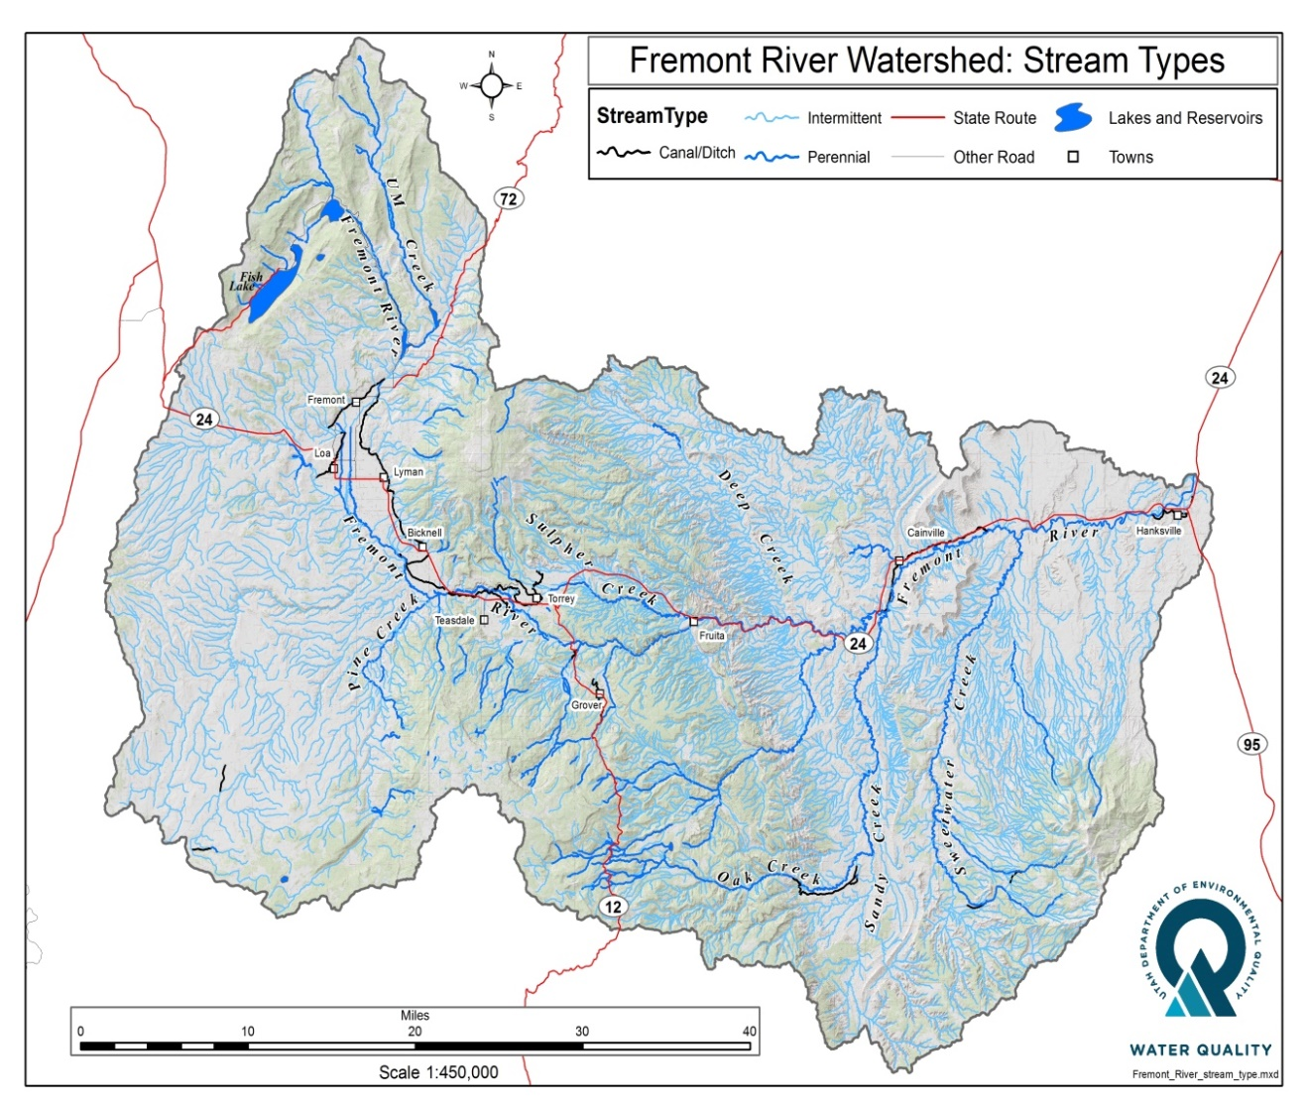
Figure 4. Stream types in the Fremont River watershed

3.1.3 Water Supply and Uses
Data from the Utah Division of Water Rights (October 1, 2018) indicate that 2,855 points of diversion exist in the Fremont River watershed (Table 5, Figure 5). Water-right holders in the region include the National Park Service, energy companies, water conservancy districts, private landowners, ditch companies, irrigation companies, and the U.S. Forest Service. Underground diversions (water from wells) make up the largest type of diversion in the watershed.

Table 5. Points of diversion in the Fremont River watershed

Type of Diversion | Number | Amount (acre-feet)
Underground (Wells) | 787 | 1,119,485
Surface | 499 | 242,256
Re-diversion | 59 | 205,276
Point to Point | 1,474 | 142
Return | 23 | 141
Spring | 13 | 4
Total | 2,855 | 1,567,304

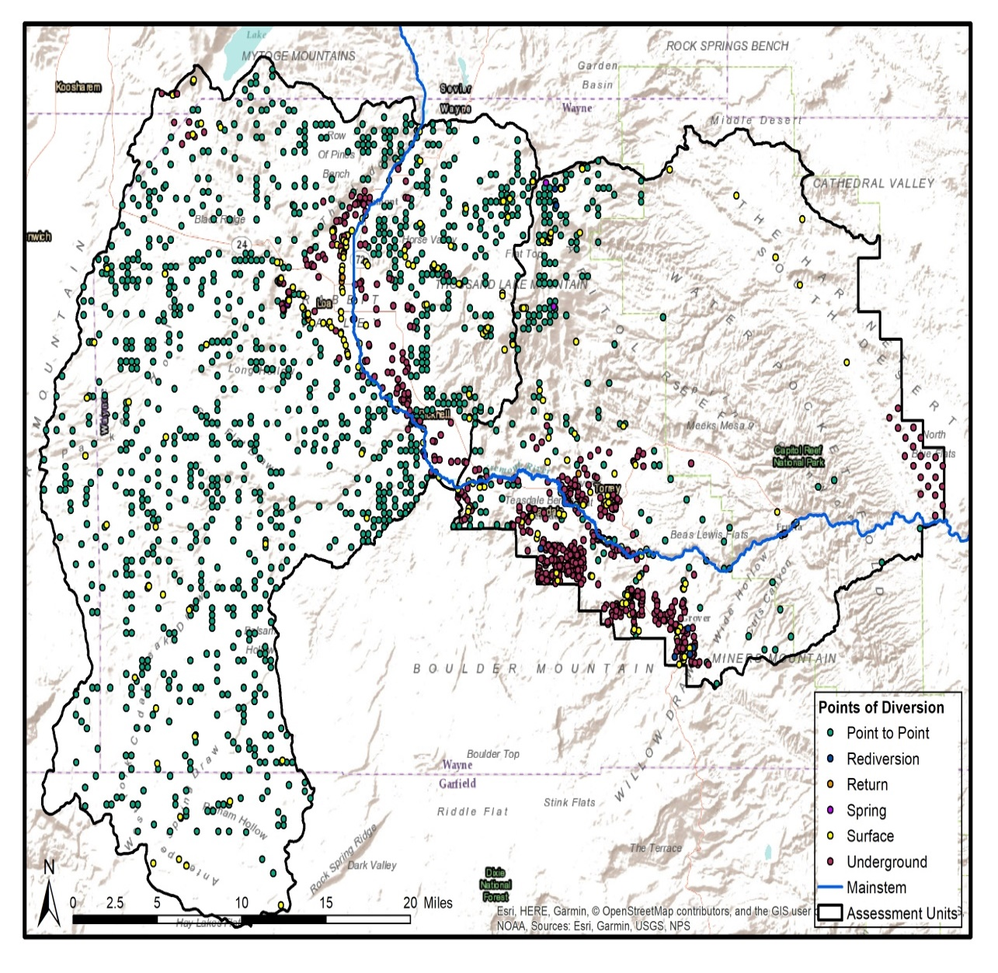
Figure 5. Points of diversion in the Fremont River Watershed

3.1.4 Precipitation and Climate
Annual temperatures and precipitation vary greatly within the watershed and are mainly tied to changes in elevation. Average annual temperatures range from 40⁰F at the high elevation headwaters near Fish Lake to 54⁰ F at Hanksville near the confluence with Muddy Creek. Precipitation primarily falls during two distinct seasons. Frontal systems from the Pacific Northwest bring winter and spring precipitation in the form of snow at higher elevations and rain at lower elevations, and late summer monsoonal rains from the south bring moisture to the entire region. Average annual precipitation ranges from five inches near Hanksville in the very dry lower portion of the watershed to approximately 40 inches in the mountains near the headwaters on the Fishlake National Forest (Figure 6) (USDA, 2019).
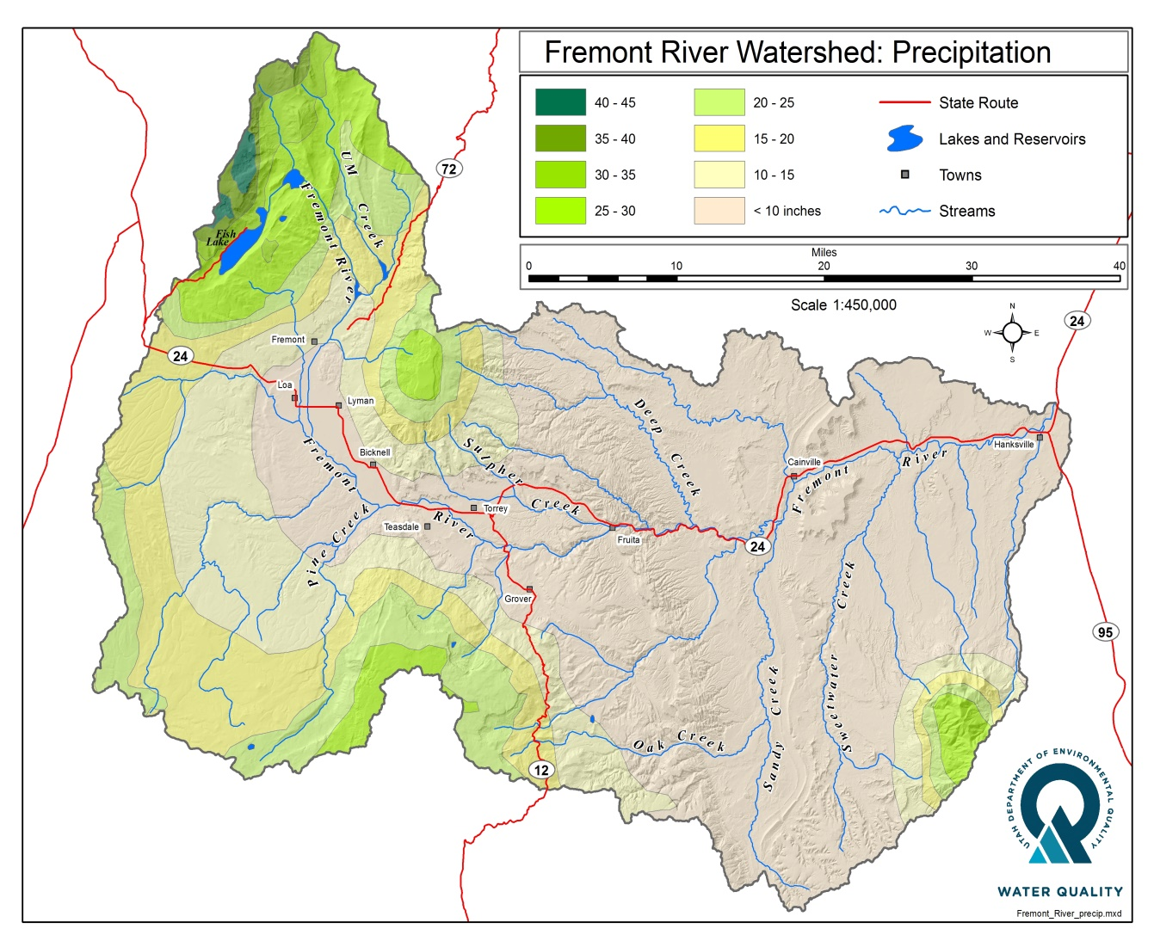
Figure 6. Annual precipitation (inches) in the Fremont River watershed

3.2 Biological Features

3.2.1 Fisheries
The main-stem Fremont River supports excellent fishing for larger trout in certain locations, and the headwater streams can offer good fishing for smaller fish. There are also small, high elevation lakes and reservoirs that support cold water fisheries.

Colorado River cutthroat trout are the only native game fish that occurs in the Fremont River watershed. Historically, the Fremont River watershed is also home to several fish species of high conservation concern within the greater Colorado River Basin, though these species are not currently thought to exist in the uppermost portion of the Fremont River. Blue-head sucker, flannel-mouth sucker, round-tail chub, humpback chub, bony tail, Colorado pike minnow, and razorback sucker are listed as “Species of Greatest Conservation Need” by the Utah Division of Wildlife Resources. Furthermore, the U.S. Fish and Wildlife Service also lists the latter four species as “Endangered.” (USDA, 2019). Blue-head and flannel-mouth suckers occur in Capitol Reef National Park.

3.2.2 Wildlife
The Fremont River watershed provides habitat for several game and non-game wildlife species that are socially, economically, and biologically important to the area. Some of the more common species likely contribute to natural background E.coli loads in the Fremont River watershed. Big game species include mule deer, Rocky Mountain elk, desert bighorn sheep, and American pronghorn. Other game species include black bear, cougar, cottontail rabbit, snowshoe hares, chukar partridge, California and gambel quail, Chinese ringneck pheasant, wild turkey, and waterfowl. Furbearers include bobcat, beaver, raccoon, badger, striped skunk, muskrat, red fox, gray fox, and kit fox. Non-protected mammals include coyote and jackrabbit. (USDA, 2019)

A wide variety of nongame mammals and birds use this ecosystem, which ranges from subalpine forests to desert scrub. A large majority of these species utilize the drainages where perennial water sources exist. A large proportion of raptors use small mammals and birds in the ecosystem as their prey base, especially during the winter months. Many golden eagles, ferruginous hawks, and rough-legged hawks using this area seasonally.

The Bicknell Bottoms 670 acre Wildlife Management Area (WMA) west of Torrey attracts a large number of waterfowl and other birds. The area is a Utah Division of Wildlife Resources managed wetland complex along the Fremont River and Pine Creek. Although waterfowl contribute to E. coli loading in the watershed the monitoring location established approximately 1 mile downstream from the WMA boundary does not indicate significant bacteria loading from that area. Of 32 E. coli samples collected between 2016 and 2018, only two exceeded the maximum standard (6%).

One challenge with managing big game herds in the Fremont River watershed is easy access to agricultural lands. Agricultural fields are being utilized more for a feed resource, and as many of these pastures are adjacent to waterways, there is potential for E. coli loading from big game herds from those areas.

Greater sage-grouse occur in the Fremont River watershed, with the population on Parker Mountain being one of the largest populations in the State of Utah. This watershed also contains populations of endangered Southwest willow flycatchers as well as the threatened Utah prairie dogs and yellow-billed cuckoos.
It is important to be aware of any protected plant and animal species within a watershed where best management practices are recommended. Extra considerations may be necessary prior to project implementation. The U.S Fish and Wildlife Service website provides a list of threatened and endangered species by county. Results for Wayne County, which includes the majority of the Fremont River watershed, include four bird species, four fish species, seven flowering plants and one mammal. This list, along with additional information, can found in Appendix F.

3.3 Land Use

3.3.1 Land Ownership
Various federal, state, and private entities are responsible for managing land throughout the Fremont River watershed. The Bureau of Land Management manages the majority of the land in the Fremont River watershed (41% of the total). The U.S. Forest Service manages the second largest amount (30%), which is composed of most of the land in the headwaters areas (Table 6, Figure 7).

Table 6. Land ownership in the Fremont River watershed

Landowner | Area (acre) | Area (mi²) | Percent (%)
Bureau of Land Management | 517,736 | 809 | 40.9
National Forest | 376,420 | 588 | 29.7
National Parks | 166,285 | 260 | 13.1
State Trust Land | 140,651 | 220 | 11.1
Private | 64,415 | 101 | 5.1
State Wildlife Area | 775 | 1.2 | 0.1
Total | 1,266,282 | 1,979.2 | 100

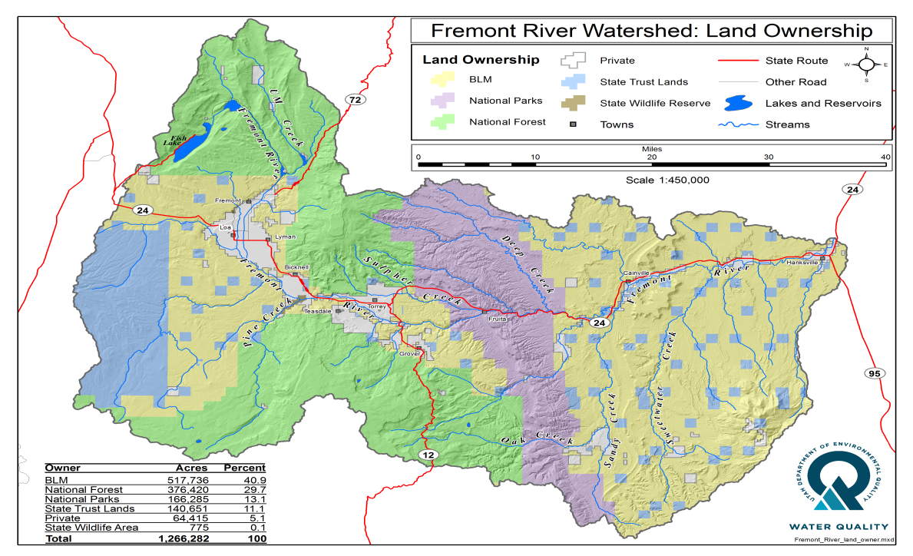

Figure 7. Land Ownership in the Fremont River Watershed

3.3.2 Land Cover and Water Related Use
Land cover impacts the flow of water across the landscape and is an important parameter to consider when determining E. coli loads to receiving waterbodies. Generalized vegetation communities in the Fremont watershed are, in order: high elevation to low include coniferous forests, sagebrush grasslands, Pinyon-Juniper woodlands, shadscale deserts, and greasewood flats (Table 7, Figure 8).

Vegetation at the lower elevations within the Fremont watershed includes cottonwood trees, salt cedar, and numerous shrubs such as sagebrush, greasewood, willows, and wild rose. Higher in the mountain canyons, the streams are lined with willow, alder, and thickets of rose. The dominant land cover types are desert shrubs, juniper, and sagebrush. (USDA, 2019)

Water-related land use is predominately associated with irrigation of alfalfa and grass hay. Most irrigation occurs in the Rabbit Valley area from Loa downstream to Torrey and has been upgraded to sprinklers. Historic fruit orchards are flood irrigated in Capitol Reef National Park. In some areas throughout the watershed irrigation, return flows spill back into the river. This water has the potential to carry fecal pathogens, including E. coli, picked up via overland flow.
Table 7. Dominant land use and cover throughout the Fremont River watershed

Land Cover | Acres | Percent
Pinyon-Juniper | 320,106 | 25.4
Desert shrub | 284,647 | 22.6
Sagebrush | 192,094 | 15.2
Spruce-Fir | 151,507 | 12
Grasslands | 151,505 | 12
Aspen | 120,423 | 9.6
Mountain brush | 7,632 | 0.6
Land Use

Agricultural | 21,191 | 1.7
Riparian | 6,171 | 0.5
Water | 5,663 | 0.4
Urban | 4,037 | 0.3
Total | 1,260,939 | 100

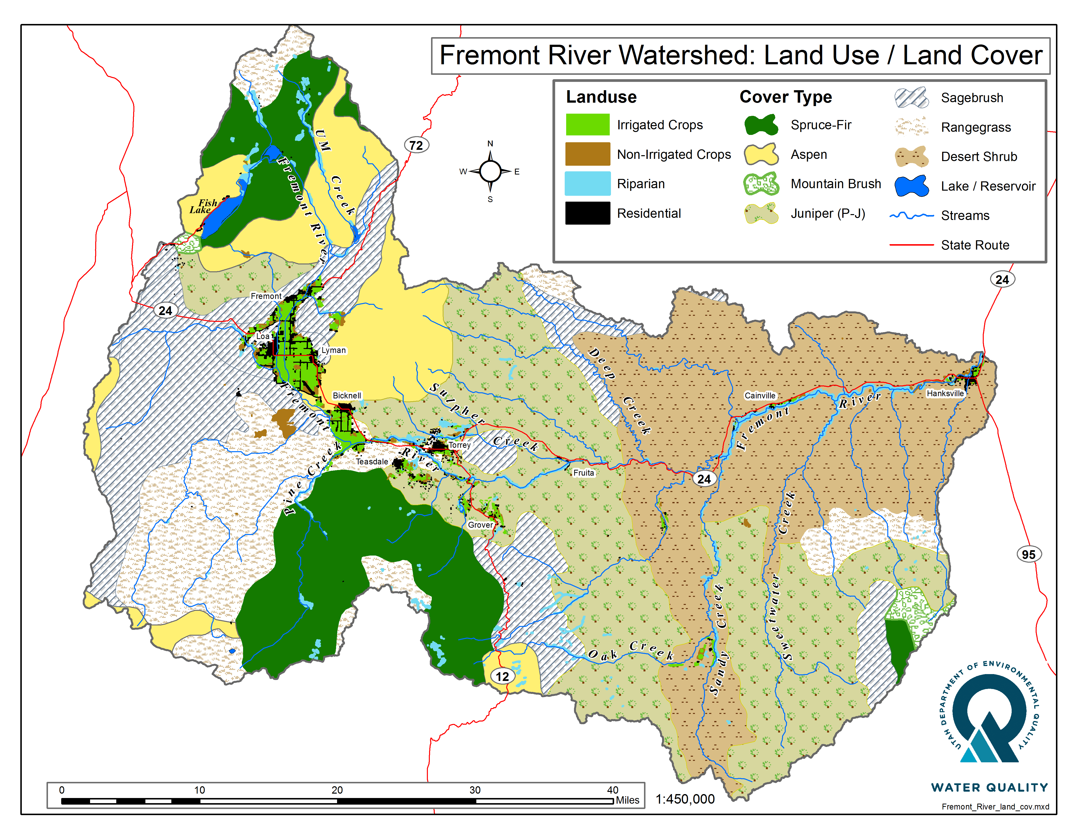

Figure 8. Dominant vegetation and land use in the Fremont River Watershed

4.0 WATER QUALITY DATA

4.1. Previous Bacteria Water Quality Study
The National Park Service (NPS) Northern Colorado Plateau Network collected E. coli samples in three Fremont River tributaries in Capitol Reef National Park (Park) from July 2008 to September 2017. The NPS increased collection efforts in response to the 2014 Integrated Report 303(d) listing of the Fremont River-3 for E. coli exceedances that year. Samples were collected monthly at two locations on Sulphur Creek, and one location each in Pleasant Creek (4954780) and Oak Creek (4954795) (Figure 9). Only one of these four monitoring locations (lower Sulphur Creek: 4954770) coincided with a DWQ monitoring location that was established for this TMDL study. E. coli concentrations exceeded both chronic and acute (maximum) state water-quality standards for recreational use at all four water-quality sites within the park (Hackbarth, 2018).

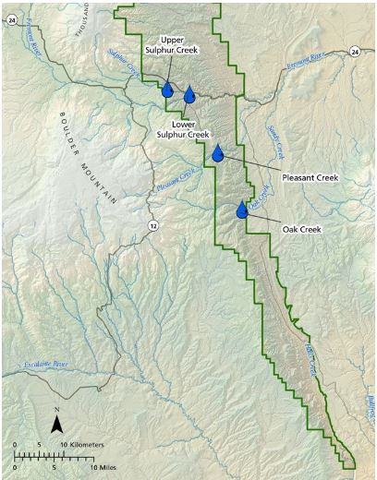

Figure 9. Monitoring locations from NPS E. coli study
E. coli exceedances occurred during low flow and low turbidity conditions at all four monitoring locations, suggesting that E. coli contamination is not isolated to flood events. Most exceedances occurred during the state-defined recreation season of May 1–October 31. This timeframe encompasses over 75% of the park’s annual visitation and also corresponds to cattle trailing through Oak, Pleasant and Sulphur Creeks and the Fremont River in the park en route to the Lower South Desert, and dispersed livestock grazing on public lands upstream of the park in all three sub-watersheds. Paired samples taken in Sulphur Creek near the park’s west boundary and in the park developed zone at the picnic area, above and below a popular hiking route, showed similar patterns in E. coli concentrations, suggesting that in Sulphur Creek, most E. coli contamination enters upstream of Capitol Reef National Park rather than from park visitation or infrastructure. Upstream and downstream comparisons are not available for Oak Creek and Pleasant Creek, which have less park infrastructure and visitation than Sulphur Creek.

Results from the NPS study supplemented the data collected by DWQ and Utah State University (USU) Extension staff as part of this TMDL and helped identify potential sources of bacteria loading in the watershed.

4.2 Flow Data
The only active stream flow gage in the Fremont River watershed is operated and maintained by the United States Geological Survey, with a period of record from 1976-present at that location. The gage is USGS 09330000 Fremont River near Bicknell, UT (Figure 11). Mean annual flows range between 60.2 (1980) and 138.4 (1985) cfs. Mean monthly discharges from 1986 to present can be seen in Figure 10. Flow at this location is substantially influenced by upstream diversions.

Flow measurements are critical for calculating pollutant loading in the river. Field monitoring personnel have consistently measured stream flow at all monitoring locations since 2017. Sampling prior to that did not include flow measurement. For instances when flow was not measured at the two target monitoring locations (Fremont River at Big Rocks Rd and Fremont River at U12 Crossing), flow was estimated using a simple linear regression based on the measured flows versus flows at the USGS Bicknell gage. For the Fremont River at Big Rocks Road the r² between the measured flow observations and the downstream flow gage measurements was 0.86. There were 8 measured flow observations and 23 estimated flows between 2016-2018. For the Fremont River at U12 Crossing the r² between the measured flow observations and the upstream flow gage measurements was 0.56. There were 18 measured flow observations and 68 estimated flows between 2008-2018. Measured and modeled flow values used for loading calculations can be found in Appendix F. The gage is located several miles from each of the target locations and there is considerable hydromodification throughout the watershed but this approach increased the number of flow observations for TMDL calculations, and therefore increased the confidence in the resulting necessary load reductions for each AU.

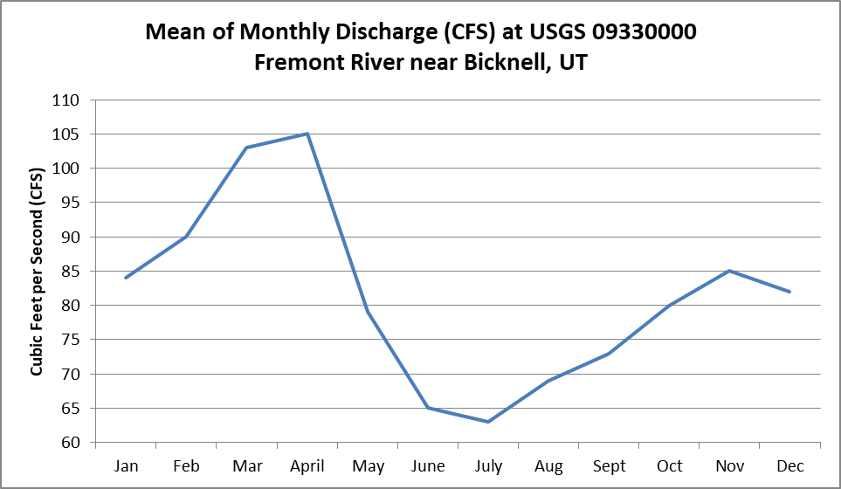

Figure 10. Mean of monthly discharge (cfs) at USGS 09330000 Fremont River near Bicknell, UT

4.3 Monitoring Results
Several monitoring locations (Figure 11) were established to better understand the temporal and spatial extent of impairment throughout the watershed in response to the 2014 303(d) listing. The Fremont River was first listed as 303(d) impaired for E. coli during the 2012-14 Integrated Report process. The impairment was based on exceedances measured at the following three monitoring locations in the Fremont River-3 AU:
- 4954390: Fremont River at U12 Crossing
- 4954480: Fremont River at Campground in Fruita
- 4954356: Fremont River at Falls 1.2 miles above the Confluence with Deep Creek
The upstream-most site established for this TMDL study is in the town of Loa on Spring Creek (4955310). There are only two monitoring locations in the Fremont-2 AU: 4955310 at Spring Creek at U24 crossing and 4955330 at Fremont River at Big Rocks Road. The remaining sites are in the Fremont-3 AU. The downstream-most site is the Fremont River at the Hickman Bridge Trailhead (4954360).
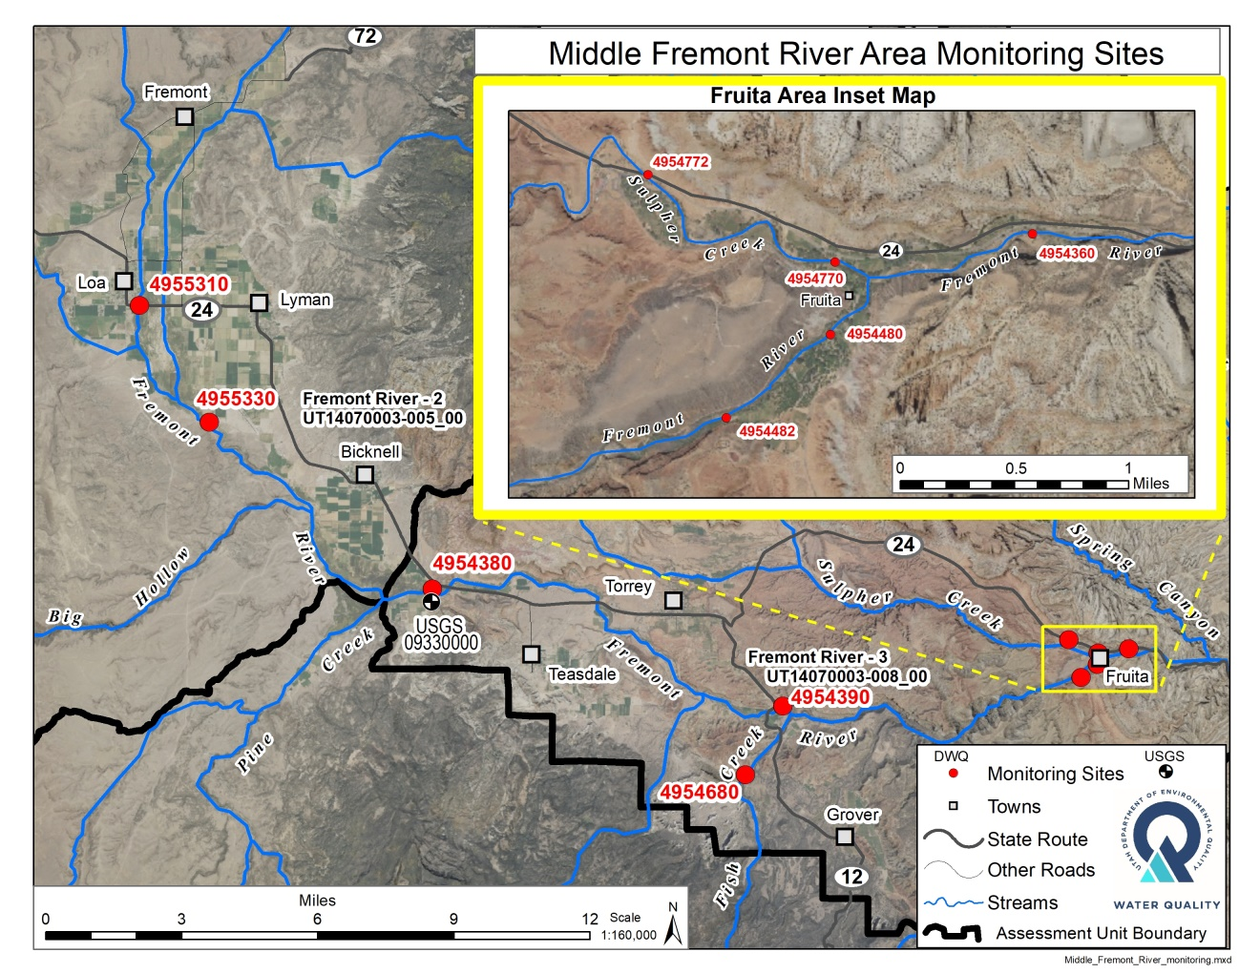
Figure 11. Fremont River E. coli monitoring locations

Table 8 includes E. coli summary statistics for the Fremont River watershed monitoring locations. It includes:
- The number of samples collected during the recreation season and year-round
- The data range
- The minimum and maximum reported E. coli concentrations for each location
- The geometric mean of all samples collected within the recreation season
Sites are listed upstream to downstream, and those highlighted in red triggered the 2014 303(d) listing.
Table 8. E. coli summary statistics for Fremont River watershed monitoring locations. Sites are listed upstream to downstream. Site IDs shown in red triggered the 303(d) listing in 2014.

Site ID | Site Name | Rec Season/All | Date Range | Minimum  E. coli (MPN/100 mL)/Month it occurred | Maximum E. coli (MPN/100 mL)/Month it occurred | Geomean of all samples  (MPN/100 mL)  Rec Season/All
4955310 | Spring Creek at U24 Crossing | 18/33 | 2016-2018 | 7.5/Jan | 2,419.6/July | 549/267
4955330 | Fremont River at Big Rocks Rd | 16/31 | 2016-2018 | 26.2/Dec | 2,419.6/Aug | 312/234
4954380 | Fremont River at Bicknell | 19/34 | 2013-2018 | 9.1/March | 1413.6/Aug | 156/95
4954390 | Fremont River at U12 Crossing | 62/86 | 2008-2018 | 1.0/April | 2,419.6/Sept | 187/102
4954680 | Fish Creek at Road Crossing | 18/33 | 2016-2018 | 1.0/Feb, May and Dec | 706.9/Oct | 39/15
4954482 | Fremont River above Hatties Field in CRNP | 42/57 | 2011-2018 | 2.0/May | 981.5/July | 93/63
4954480 | Fremont River at Campground in Fruita | 59/76 | 2010-2018 | 4.6/March | 1894.0/Aug | 184/115
4954360 | Fremont River at Hickman Bridge Trailhead | 19/34 | 2013-2018 | 4.0/March | 706.5/July | 141/67
4954772 | Sulphur Creek at First Road Crossing above confluence with Fremont River | 32/46 | 2013-2018 | 1.0/March | 926.0/July | 91/57
4954770 | Sulphur Creek above Fremont River at Picnic Area | 46/64 | 2012-2018 | 1.7/March | 2,192.3/June | 200/114
4954356 | Fremont River at Falls 1.2 miles above the Confluence with Deep Creek | 47/61 | 2008-2015 | 2.0/Dec | 1106.0/Aug | 169/128
4954795 | Oak Creek above Sandy Ranch Dam | 8/10 | 2016-2017 | 1.0/April and May | 166.4/Oct | 11.2/12.2
4954780 | Pleasant Creek South of Sleeping Rainbow Ranch | 8/10 | 2016-2017 | 1.0/April, May and Nov | 307.6/Aug | 11.9/14.4

Table 9 shows the results of one of the three assessment scenarios that were performed as part of the Integrated Report’s E. coli assessment methodology (see Appendix A).

Seasonal assessment
The seasonal assessment against the maximum criterion states that “for each monitoring location with >5 collection events in any recreation season, no more than 10% of samples collected from May 1st through October 30th may exceed 409 MPN/100 mL for 2A waters” (DWQ, 2014 IR). Both monitoring locations within the Fremont-2 AU exceed that, and as a result, the Fremont-2 AU will be included in the next 303(d) list as part of the 2018/2020 Integrated Report. Three of the ten monitoring locations in the Fremont-3 AU exceed the 10% threshold.

Table 9. Percent exceedance of 2A maximum criterion (409 MPN/100mL) for Fremont River watershed monitoring locations

Assessment Unit | MLID | Site Description | % Exceedance  409 MPN/100mL max criterion
Fremont River-2:  Fremont River and tributaries from Bicknell to Mill Meadow Reservoir near USFS boundary | 4955310 | Spring Creek at U24 Crossing | 44%
 | 4955330 | Fremont River at Big Rocks Rd | 35%
Fremont River-3:  Fremont River and tributaries from east boundary of Capitol Reef National Park to Bicknell | 4954380 | Fremont River at Bicknell | 6%
 | 4954390 | Fremont River at U12 Crossing | 19%
 | 4954482 | Fremont River above Hatties Field in CRNP | 5%
 | 4954480 | Fremont River at Campground in Fruita | 16%
 | 4954360 | Fremont River at Hickman Bridge Trailhead | 3%
 | 4954680 | Fish Creek at Road Crossing | 3%
 | 4954772 | Sulphur Creek at First Road Crossing above confluence with Fremont River | 7%
 | 4954770 | Sulphur Creek above Fremont River at Picnic Area | 20%
 | 4954795 | Oak Creek above Sandy Ranch Dam | 0%
 | 4954780 | Pleasant Creek South of Sleeping Rainbow Ranch | 0%

Seasonal geometric mean
Table 10 reflects another of the three assessment scenarios: seasonal geometric mean assessment. For each AU with ≥10 collection events in any recreation season, the geometric mean of all samples should not exceed 126 MPN/100 mL for 2A waters. It is important to note that none of the Fremont River watershed monitoring locations had a sufficient number of samples collected in any recreation season to apply this assessment scenario. However, even with an insufficient numbers of samples, it is still useful to consider the recreation season geometric mean to get a general sense of which sites have elevated concentrations. Future monitoring may include collection of 10 or more samples during the recreation season.

Table 10. Summary of monitoring location recreation season geometric means. Geometric means highlighted in red exceed the seasonal geometric mean of 126 MPN/100 mL.

AU | Site ID | Site Name | 2011 | 2012 | 2013 | 2014 | 2015 | 2016 | 2017 | 2018
Fremont River- 2 | 4955310 | Spring Creek at U24 Crossing |  |  |  |  |  | 660.3 | 658.6 | 380
 | 4955330 | Fremont River at Big Rocks Rd |  |  |  |  |  | 272 | 221.5 | 452.1
Fremont River-3 | 4954380 | Fremont River at Bicknell |  |  |  |  |  | 89.7 | 143.3 | 377.7
 | 4954390 | Fremont River at U12 Crossing | 336.6 | 123.6 | 650.2 | 136.1 | 271.5 | 102.5 | 204 | 176.5
 | 4954482 | Fremont River above Hatties Field in CRNP | 211.8 | 51.2 | 91.5 | 56 | 54.4 | 142.2 | 87.3 | 98.2
 | 4954480 | Fremont River at Campground in Fruita | 402 | 82.5 | 497.2 | 224.3 | 132.3 | 119.9 | 120.7 | 71.7
 | 4954360 | Fremont River at Hickman Bridge Trailhead |  |  |  |  |  | 192.4 | 166.7 | 87.7
 | 4954680 | Fish Creek at Road Crossing |  |  |  |  |  | 80.6 | 24.6 | 29.7
 | 4954772 | Sulphur Creek at First Road Crossing above confluence with Fremont River |  |  | 100.4 | 114.2 | 253.7 | 43.9 | 58.2 | 99.9
 | 4954770 | Sulphur Creek above Fremont River at Picnic Area |  | 539.4 | 186.1 | 270.8 | 216.2 | 225.5 | 162.8 | 134.4
 | 4954795 | Oak Creek above Sandy Ranch Dam |  |  |  |  |  |  | 12.7
 | 4954780 | Pleasant Creek South of Sleeping Rainbow Ranch |  |  |  |  |  |  | 14.0

4.3.1 Monitoring Location Details

(Sites listed from upstream to downstream)

Spring Creek at U24 Crossing: 4955310
Spring Creek originates at a spring located on a valley margin 2.5 miles north of Loa, Utah. The stream is diverted numerous times along its seven-mile length until it reaches the confluence with the Fremont River. Flow from the spring is a constant 13 cfs. By the time Spring Creek reaches the Highway 24 crossing south of Loa, it has flow rates that vary between four cfs during irrigation diversion and 22 cfs during spring runoff. The stream follows generally the same course as the one surveyed in the late 1800s, but considerable straightening and diverting have occurred since that time. The creek carries a substantial amount of irrigation return flow. It is bordered by irrigated pastures that are often grazed by cattle, sheep, and wildlife.

Based on data from this monitoring station, the Fremont River-2 AU was listed as impaired for temperature and pH in the 2014 Integrated Report. This TMDL, however, focuses solely on the E. coli impairment. Based on recent data (44% of E. coli samples collected from 2016-2018 exceeded the recreation use standard), the Fremont-2 AU will be listed as impaired for E. coli as part of the 2018/2020 Integrated Report in 2020 (Figure 13).

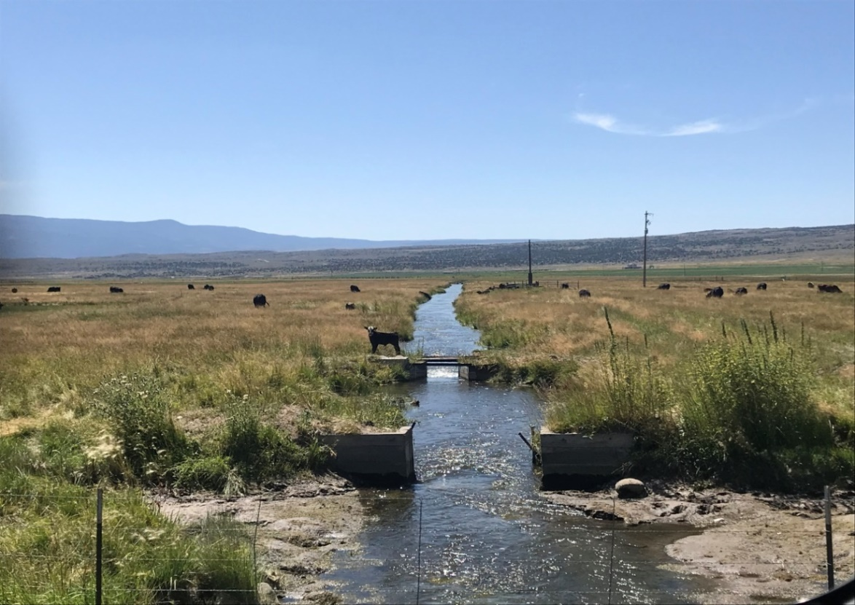

Figure 12. Image of 4955310: Spring Creek at U24 Crossing, September 2019

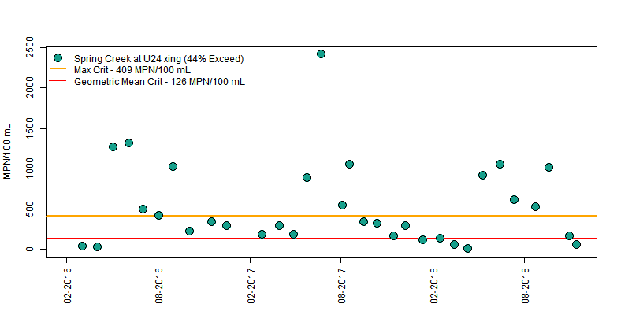

Figure 13. E. coli concentrations at 4935310 Spring Creek at U24 Crossing from 2016-2018

Fremont River at Big Rocks Road: 4955330
The Fremont River channel between Mill Meadow Reservoir and Spring Creek is generally dry most of the year as water is held in the reservoir or diverted just below the reservoir for irrigation. The confluence of the Fremont River and Spring Creek is less than a mile upstream of this monitoring location. Spring Creek contributes a majority of the flow, with the slight addition of some springs and irrigation return flows. This site has the potential to be dry at times throughout the year depending on upstream water diversion and use. Flow slows as it moves through this marshy area. Thirty-five percent of E. coli samples collected from 2016-2018 exceeded the maximum criterion recreation use standard (Figure 14).

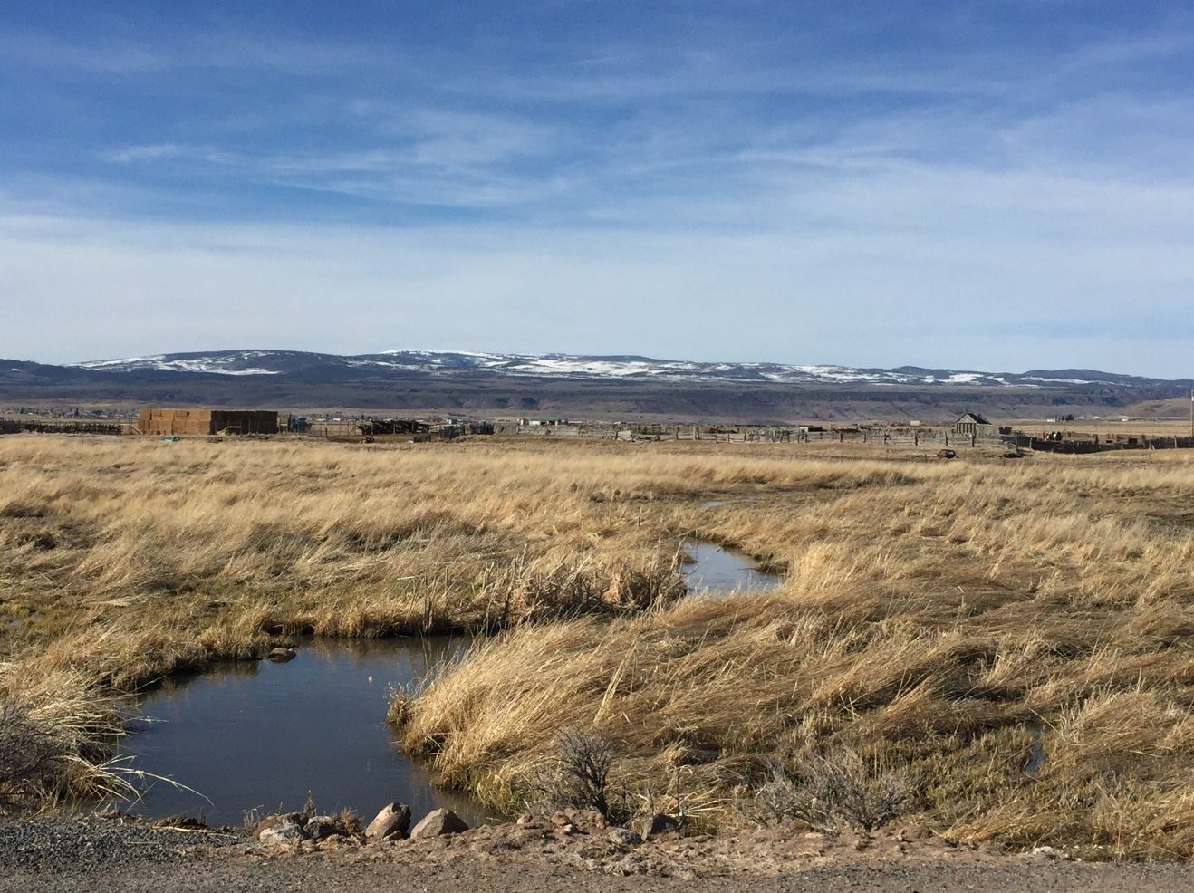

Figure 14. Image of 4955330: Fremont River at Big Rocks Road

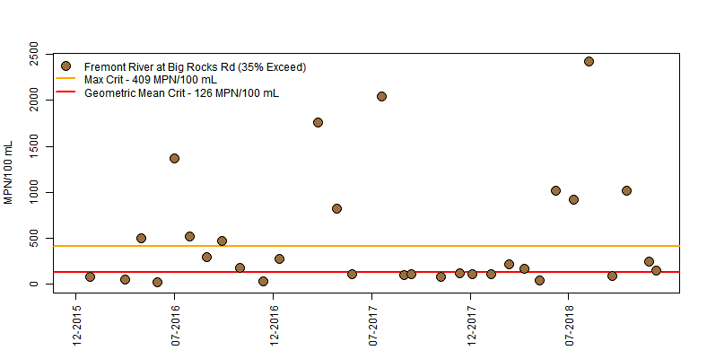

Figure 15. E. coli concentrations at 4955330 Fremont River at Big Rocks Road from 2015-2018

Fremont River at Bicknell: 4954380
As the Fremont River flows downstream of Big Rocks Road, the tributaries of Pine Creek and Government Creek as well as several springs, join it. This is the only location with an active USGS flow gage (USGS 09330000) in the watershed. Approximately 10-30% of the flow at this location comes from Spring Creek based on paired flow measurements of both monitoring locations.
This is the uppermost monitoring location in the impaired Fremont-3 AU. Even when upstream monitoring locations have E. coli exceedances, the concentrations usually drop below the water quality standard at this Bicknell location. Of 32 samples collected between 2016 and 2018, only two exceeded the maximum standard (6%) (Figure 17), indicating that the upper impaired Fremont-2 AU has a minimal impact on the water quality of the adjacent downstream Fremont River-3 AU.

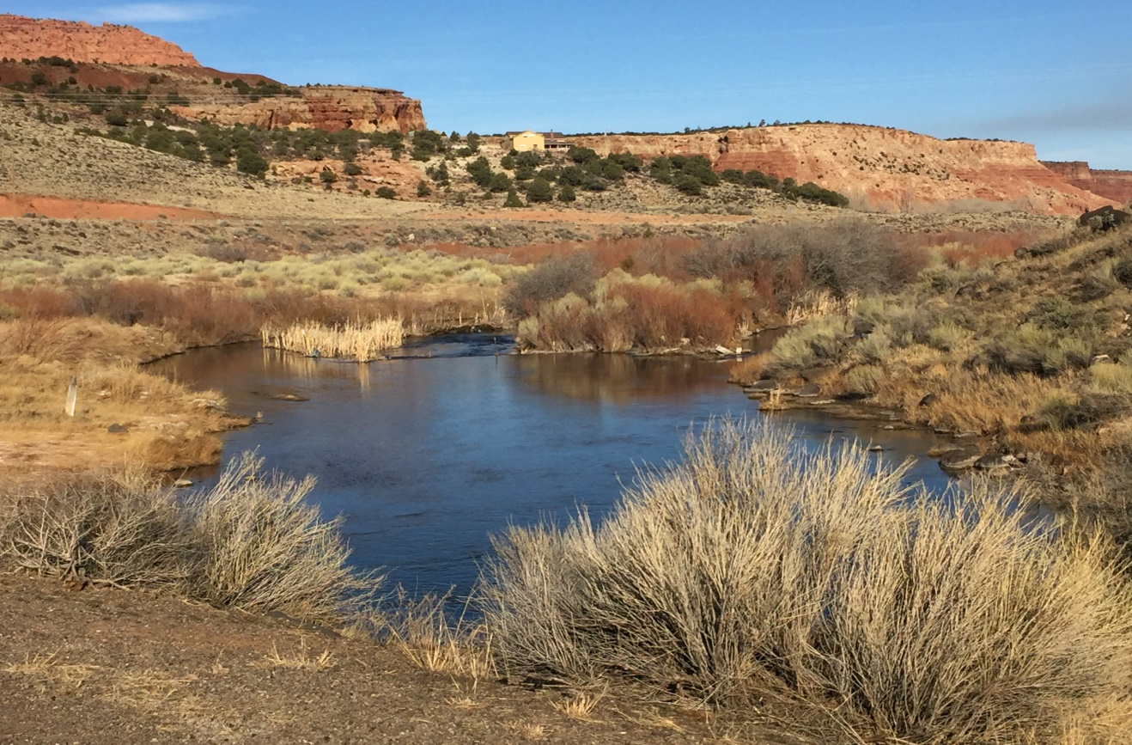

Figure 16. Image of 4954380: Fremont River at Bicknell

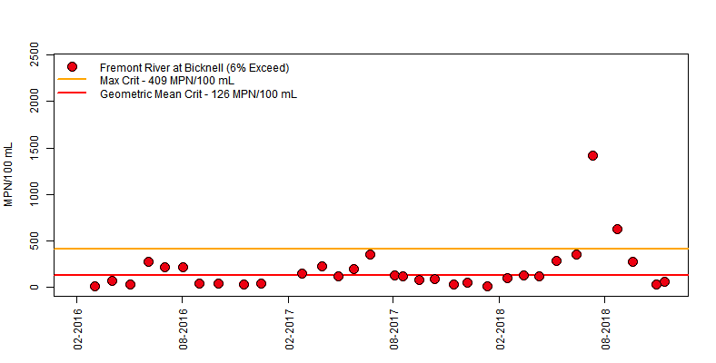

Figure 17. E. coli concentrations at 4954380 Fremont River at Bicknell from 2016-2018

Fremont River at U12 Crossing: 4954390
The Fremont River continues downstream from the Bicknell site, where much of the river is diverted for irrigation in and around the towns of Torrey, Teasdale, and Grover, Utah. Flow increases with additional spring inputs below Bicknell. The river flows through several miles of irrigated pastures that are often grazed by cattle and wildlife just upstream of this Highway 12 monitoring location. E. coli exceedances at this site triggered the original 303(d) listing in 2014 for the Fremont-3 AU. This site was the first to be monitored in the watershed, with the earliest samples collected in 2008. Nineteen percent of samples collected at this location between 2008 and 2018 exceeded the maximum standard (Figure 18).

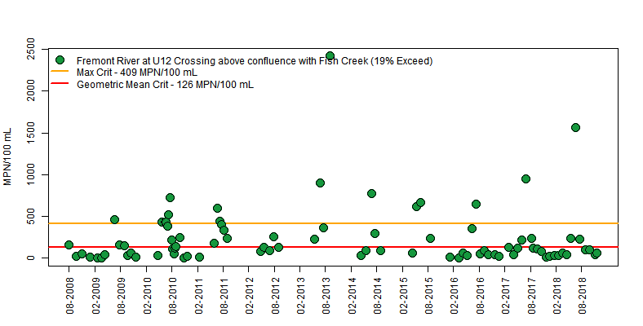

Figure 18. E. coli concentrations at 4954390 Fremont River at U12 Crossing from 2008-2018

Fish Creek at County Road Crossing: 4954680
Fish Creek originates in the high elevations of Boulder Mountain and flows northeast down to its confluence with the Fremont River. The Fish Creek monitoring location was established to get a sense of E. coli loading from perennial flowing streams with grazing allotments on US Forest Service land near the headwaters. There is a small development called Fish Creek Cove with several homes just upstream of this monitoring location. This site consistently had low E. coli concentrations with only one exceedance of the 2A maximum criterion measured out of 30 monitoring events (3%) (Figure 19).

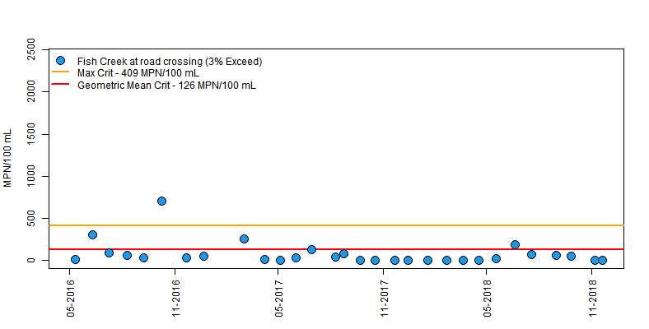

Figure 19. E. coli concentrations at 4954680 Fish Creek at County Road Crossing from 2016-2018

Fremont River above Hatties Field in Capitol Reef National Park: 4954482
Below the Highway 12 crossing, Fish Creek and Carcass Creek join the Fremont River as it flows approximately five miles downstream into Capitol Reef National Park. The river moves through steeper-walled rocky terrain that is difficult to access. The surrounding land use shifts away from irrigated pastures and grazing.
The Fremont River above the Hattie’s Field monitoring location is in the National Park just upstream of flood irrigated fruit orchards and the park campground. This location was first sampled for E. coli in 2011. Since then, only 5% of monitoring events resulted in exceedances (Figure 20).

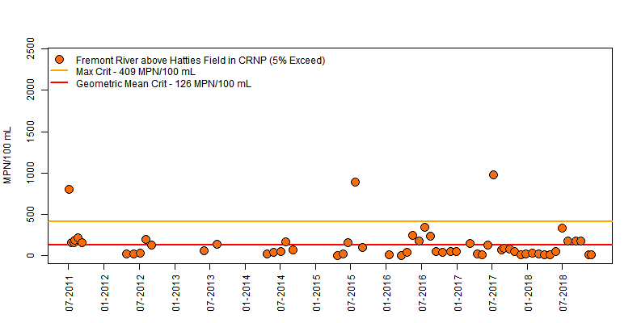

Figure 20. E. coli concentrations at 4954482 Fremont River above Hatties Field in Capitol Reef National Park from 2011-2018

Fremont River at Campground in Fruita: 4954480
This monitoring location is approximately 0.5 mile downstream of the Hatties Field site. It was established to get a better understanding of any E. coli loading from flood irrigation of the fruit orchards and a pasture grazed by horses that are adjacent to the river. This site is popular for people recreating in the river during the warm summer months of the recreation season. Most of the campsites are within close proximity to the river, with easy access down to the water. Results show an increase in percent exceedance from 5% to 16% compared to the upstream site above Hatties Field (Figure 20 and Figure 21).

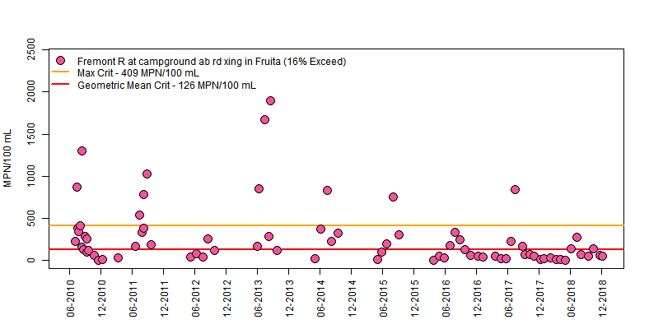

Figure 21. E. coli concentrations at 4954480 Fremont at Campground in Fruita from 2010-2018

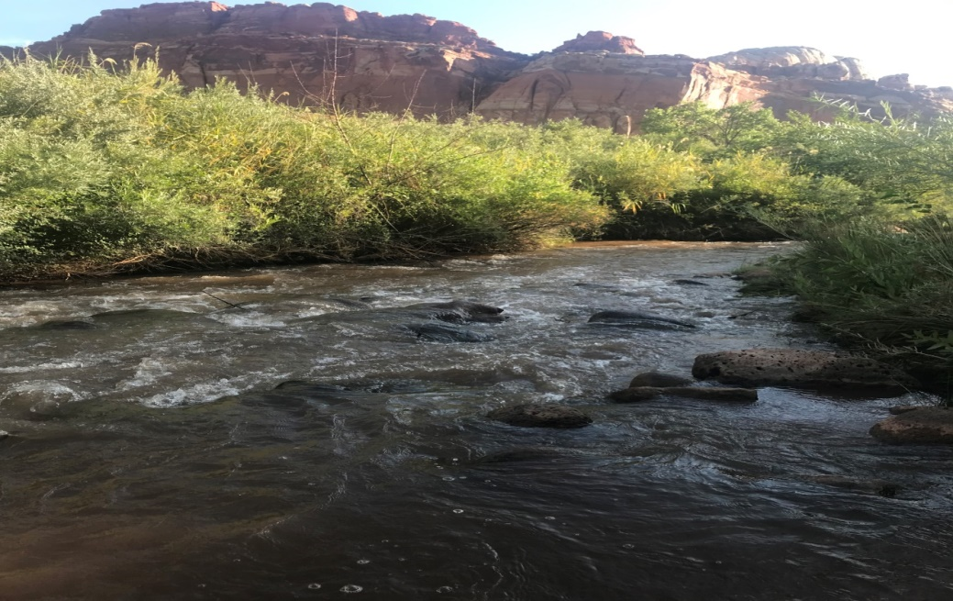

Figure 22. Image of 4954480: Fremont River at Campground in Fruita, August 2019

Sulphur Creek at First Road Crossing above confluence with Fremont River: 4954772
Sulphur Creek flows six miles within the Park before its confluence with the Fremont River. Annual peak flows ranged from 78 to 2,600 cfs between 1959 and1974 (Sulphur Creek near Fruita, USGS gage number 09330120). Recently measured (2014-2017) non-flood flows are generally one to five cfs, decreasing to zero during summer months due to lower spring and snow input as well as upstream diversions.

Sulphur Creek is a popular hiking route for Park visitors, with many people hiking in and along it just upstream of this monitoring location. Monitoring results from 2013-2018 show a 7% exceedance of the Utah maximum criterion standard (Figure 23).

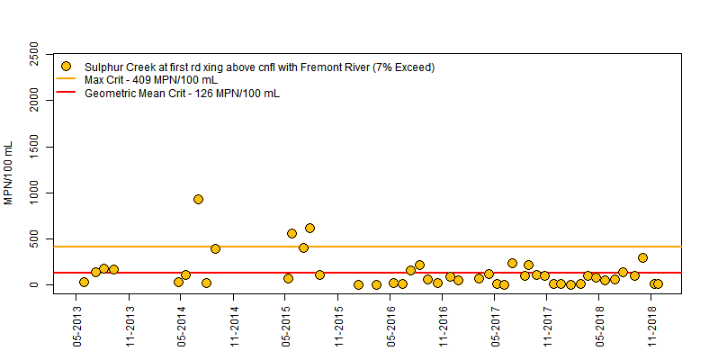

Figure 23. E. coli concentrations at 4954772 Sulphur Creek at First Road Crossing above confluence with Fremont River from 2013-2018

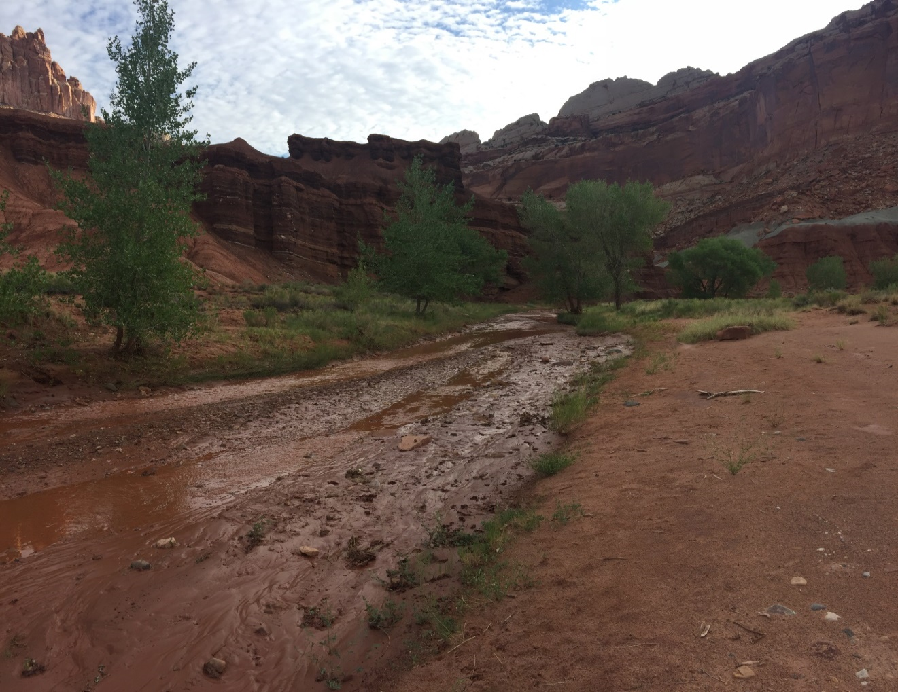

Figure 24. Image of 4954772: Sulphur Creek at first road crossing above Fremont River. August 2019

Sulphur Creek above Fremont River at the Picnic Area: 4954770
This monitoring location is 1.3 miles downstream of Sulphur Creek at the road crossing (4954772). There are potential sources of pathogen-loading between the two sites including return flows from fruit orchards that are flood irrigated using Fremont River water, and an onsite septic system that manages the waste from the Park’s visitor center, administrative offices, and employee housing. Similar to other monitoring locations in the park, many people recreate in the water here. It generally has very low flow and several easy access points. There is an increase in E. coli exceedances from 7% at the upper Sulphur Creek site (Figure 23) to 20% at the lower (Figure 25). This is higher than what was observed in the NPS study in which the Park monitored for a longer period of time (2008-2017) at this picnic area monitoring location and the upstream site on Sulphur Creek near the Park’s west boundary. That study showed no significant difference in E. coli concentrations between the two Sulphur Creek monitoring locations. Future monitoring could include a Sulphur Creek site upstream of the Park boundary to better characterize the water quality upstream of the Park.

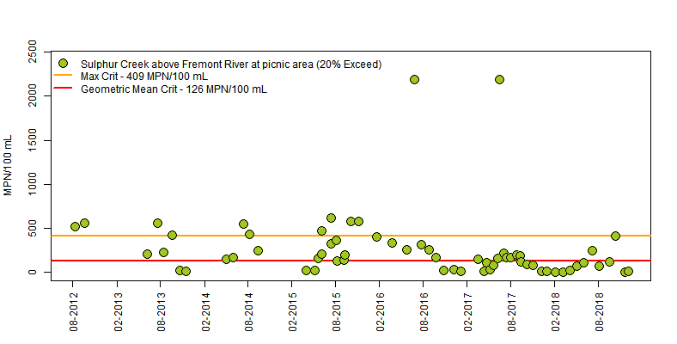
Figure 25. E. coli concentrations at 4954770 Sulphur Creek at picnic area above Fremont River from 2012-2018

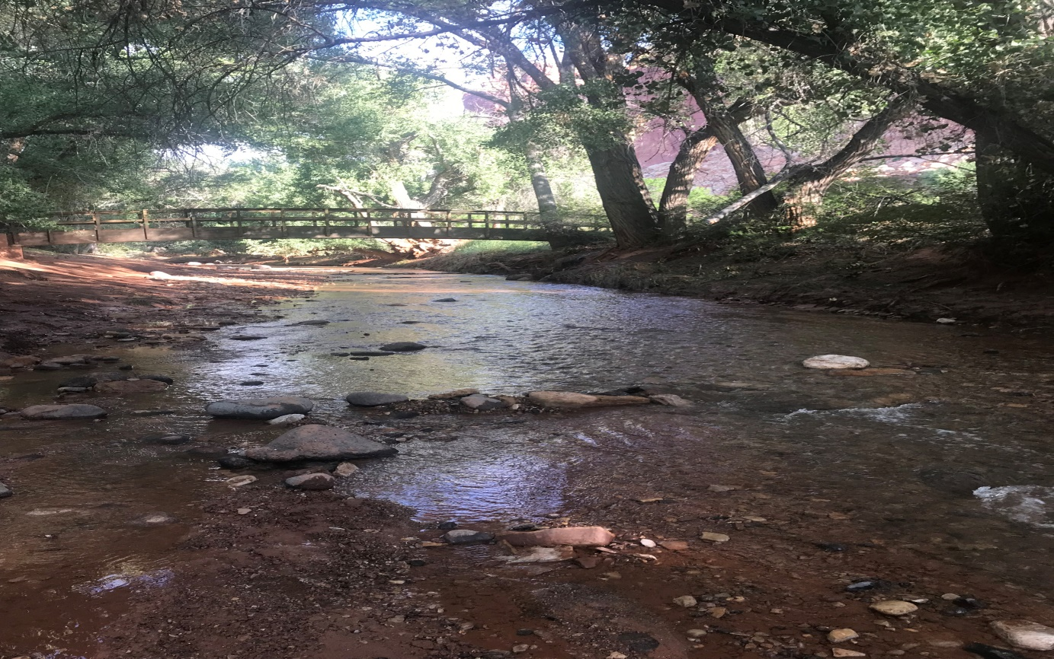

Figure 26. Image of 4954770: Sulphur Creek at picnic area above Fremont River. August 2019

Fremont River at Hickman Bridge Trailhead: 4954360
The most downstream monitoring location for this TMDL study is the Fremont River at Hickman Bridge Trailhead. It was selected to determine E. coli concentrations several miles downstream of the campground site with exceedances that triggered the 2014 303(d) listing. Between 2016 and 2018 only one sample out of 30 exceeded the maximum criterion (3%) (Figure 27).

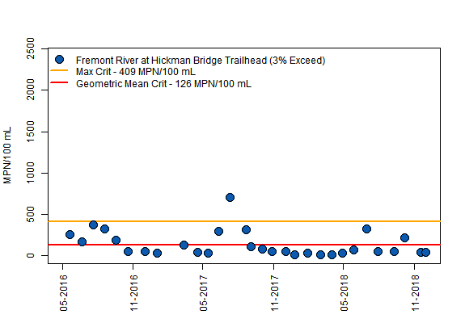

Figure 27. E. coli concentrations at 4954360: Fremont River at Hickman Bridge Trailhead from 2016-2018

4.4 Water Quality Analysis
The 2014 303(d) listing was based off of the following three monitoring locations in the Fremont-3 AU:
- 4954390: Fremont River at U12 Crossing
- 4954480: Fremont River at the campground in Fruita
- 4954356: Fremont River at Falls 1.2 miles above the confluence with Deep Creek
The target sites for the impaired Fremont-3 AU are:
- 4954390: Fremont River at U12 Crossing
- 4954480: Fremont River at the campground in Fruita
- 4954770: Sulphur Creek above Fremont River at the picnic area
Target sites were selected to get a sense of loading upstream of the Park where the greatest percent reduction in loading is required, as well as within the Park where recreation is occuring.

The target site for this TMDL for the the Fremont-2 AU is 4955330: Fremont River at Big Rocks Road. This is the most downstream monitoring location within the Fremont-2 AU and is most representative of the water quality within that stream segment.

The ultimate goal of the TMDL process is delisting of the waterbody from the 303(d) list. Information about delisting requirements can be found in Utah’s assessment methods.

4.5 Supplemental Monitoring Techniques

Pharmaceuticals and Personal Care Products
EPA defines pharmaceuticals and personal care products (PPCPs) as any product used by individuals for personal health or cosmetic reasons or used by agribusiness to enhance growth or health of livestock. PPCPs have been detected in surface and groundwater worldwide and often remain relatively persistent in the environment. Sources include elimination from the human body, flushing of unused products, leachate from landfills, rinse water from showering or bathing, and agricultural runoff. Potential health effects for humans and aquatic species are still being studied. A 2002 USGS study (Kolpin et al., 2002) found that of 130 waterways surveyed in 30 states, eighty percent contained trace amounts of PPCPs.

PPCPs analysis results can be useful in indicating failure of onsite wastewater treatment systems in a watershed. Properly sized and maintained septic tanks and leach fields allow for adequate degradation and sorption of organic wastewater compounds. However, aging and failing systems may contribute PPCPs directly or indirectly to surface and groundwater.

PPCP samples were collected in the Fremont River watershed at the following five locations:
- 4955310: Spring Creek at U24 crossing
- 4954390: Fremont River at U12 crossing
- 4954880: Fremont River at Campground in Capitol Reef National Park
- 4954772: Sulphur Creek at First Road Crossing above Fremont River
- 4954770: Sulphur Creek at picnic area above confluence with Fremont River
EPA Method 1694 was used for analysis. All results came back as non-detect suggesting that septic sources are not predominant. Analytes included hormones, prescription and over-the -counter medications, soaps, cosmetics, and cleaning products. The complete analyte list is as follows:
- Acetaminophen
- Bis Phenol A
- Butalbital
- Caffeine
- Carbamazepine
- Cotinine
- Diazepam
- Diclafenac
- Erythromycin
- Estradiol
- Estrone
- Ethinyl Estradiol
- Fluoxetine
- Gemfibrozil
- Ibuprofen
- Naproxen
- Perflourooctanoic Acid (PFOA)
- Primidone
- Progesterone
- Sulfamethoxazole
- Testosterone
- Triclosan
- Trimethoprim

5.0 TMDL

5.1 Calculation of Loading Capacity and Existing Load
The loading capacity is the amount of pollutant that can be assimilated by a waterbody while still meeting water quality standards and protecting the waterbody’s designated beneficial uses. This loading capacity is calculated by multiplying the water quality standard, the corresponding flow, and a conversion factor to determine the allowable pollutant load. The existing load is the amount of pollution that is observed in the river at the time of sample collection. This load is calculated by multiplying the measured pollutant concentration, flow, and a conversion factor. If the existing load exceeds the loading capacity, the waterbody may be assessed as impaired and loading must be reduced. The loading capacity is equivalent to the Total Maximum Daily Load (TMDL) and is allocated among identified sources, including wasteload allocations (point sources), load allocations (nonpoint sources), and a margin of safety. There are no point source wastewater discharges in the Fremont River watershed that are likely to contribute to the bacteria loading to the river, which indicates that all E. coli loading originates from nonpoint sources.

5.2 Load Duration Curve
Load Duration Curves (LDC) were calculated for the target sites to compare existing water quality conditions with those required to meet water quality standards. A LDC identifies the allowable and existing loads, uses data for all flow and loading conditions, and provides insight into critical conditions. LDCs are well-suited for analysis of periodic monitoring data collected by grab samples.
The LDC calculation included the following steps:
- Available flow data (measured and modeled) were used to generate a flow frequency table that consisted of ranking all the observed flows from the lowest observed flow to the highest. The ranked flows were plotted to create a flow duration curve.
- The flow duration curve was translated into a load duration curve by multiplying each flow by the water quality standard (126 MPN/100 mL) and a correction factor and plotting the results. This curve represents the loading capacity (or TMDL) for each observation.
- Each in-stream sample value was converted to a daily load by multiplying the observed concentration by the corresponding observed flow and a correction factor.
- The difference between the observed load and loading capacity for each flow regime quantifies the necessary load reductions during critical conditions. Both observed loads and loading capacities for conditions ranging from high flow to low flow were then graphed.
- Loads plotted above the load duration curve represent exceedances of the loading capacity. Loads plotted below the curve represent allowable daily loads and are in attainment of water quality standards.

The load duration curve approach can help identify the major issues contributing to the impairment and differentiate between various types of sources. Loads that plot above the allowable load curve in the 1-10% flow ranges (rare high-flow conditions) represent hydrologic conditions of flooding. Loads plotting above the curve between the 10-60% flow ranges likely reflect precipitation-driven contributions. Those plotting above the curve in 70-90% flow ranges are indicative of constant discharge sources. Loads that plot above the curve in greater than 90% of all recorded flows reflect hydrologic conditions of drought (Table 11).
An underlying premise of the LDC approach is correlation of water quality impairments to flow conditions. The LDC alone does not consider specific fate and transport mechanisms, which can vary depending on watershed or pollutant characteristics. The load duration approach helps identify the issues surrounding the impairment and roughly differentiate among sources. Table 11 summarizes the relationship between the five hydrologic regimes and potential contributing source areas. For example, when a stream is dominated by effluent loading under drier conditions, the loads calculated from observed in-stream data will form a linear cluster in the drier conditions of the LDC figure. If the linear cluster plots are above the LDC, then the effluent loading is causing the impairment.

Table 11. Relationship between LDC hydrologic regimes and potential contributing sources (Source: EPA 2017a)

 | Hydrologic Regime
Contributing Source Area | High | Moist | Mid-Range | Dry | Low
Point Source | L | L | L | M | H
On-site  Wastewater Treatment | L | L | L | M | L
Riparian Areas | L | H | H | H | L
Stormwater: Impervious | L | H | H | H | L
Stormwater: Upland | H | H | M | L | L
Bank Erosion | H | H | L | L | L

The load duration curves for the Fremont sites show that exceedances occur at all four target monitoring locations during all flow conditions. This indicates the potential for multiple contributing source areas in the watershed.
Load duration curves are shown below for each of the four target sites for both the calendar season (spring, summer, fall, winter) and for recreation season (recreation season versus non-recreation season) (Figures 28-35). The majority of exceedances occurred during mid- to low-flow conditions.

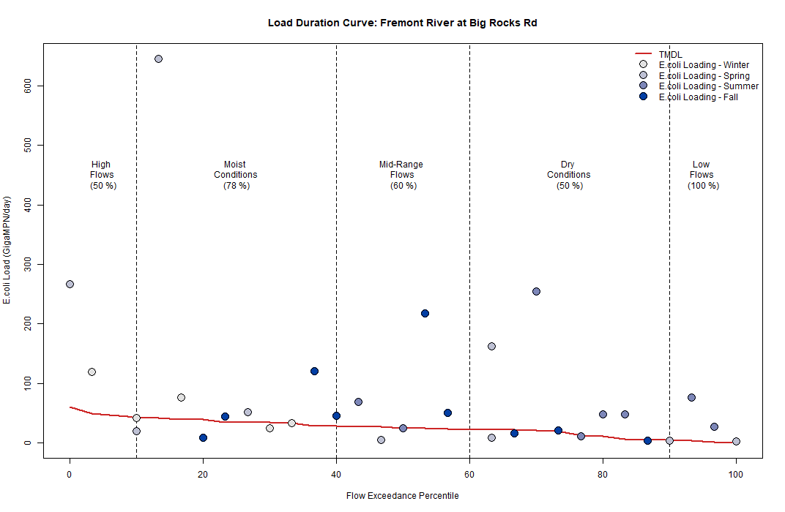

Figure 28. Calendar season load duration curve for 4955330: Fremont River at Big Rocks Road with data from 2016-2018

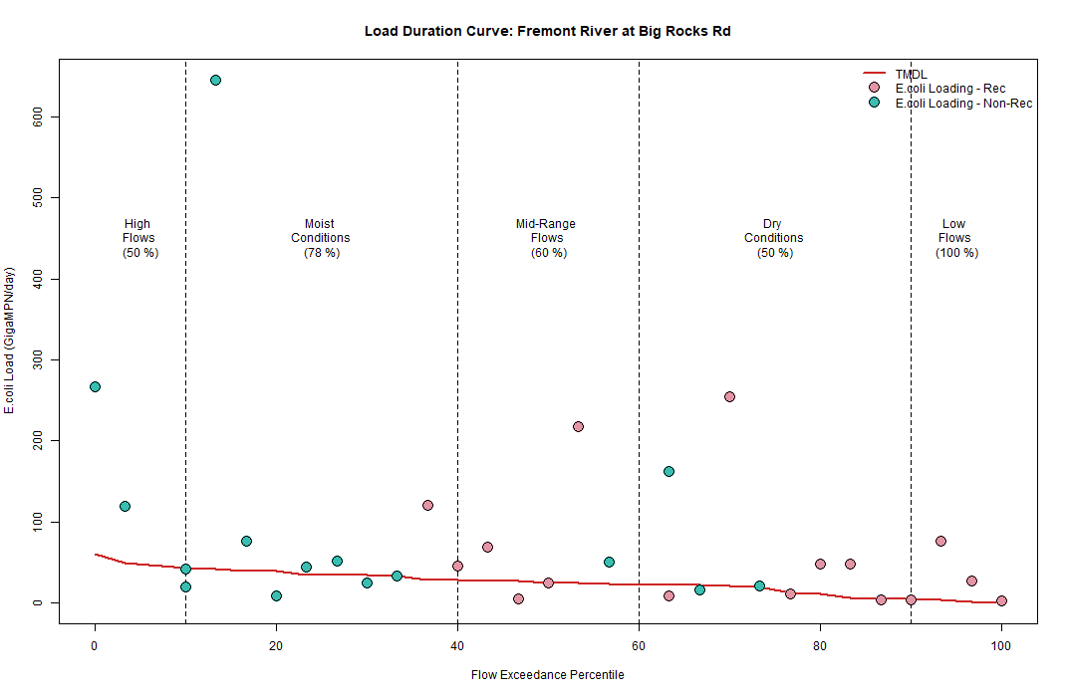

Figure 29. Recreation season load duration curve for 4955330: Fremont River at Big Rocks Road with data from 2016-2018

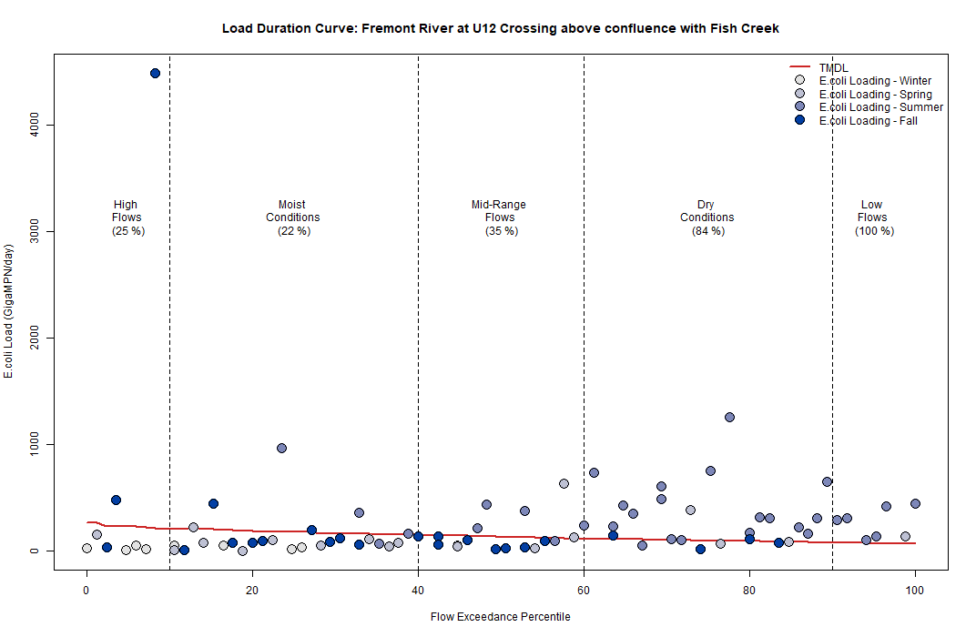

Figure 30. Calendar season load duration curve for 4954390: Fremont River at U12 Crossing with data from 2008-2018

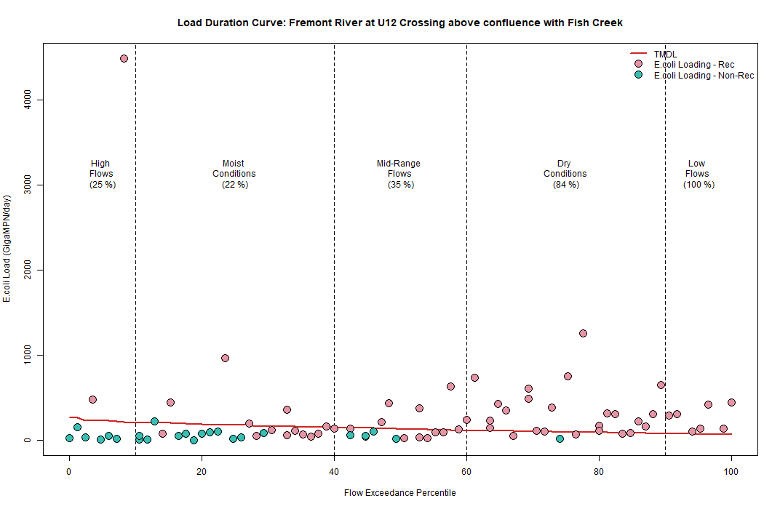

Figure 31. Recreation season load duration curve for 4954390: Fremont River at U12 Crossing with data from 2008-2018

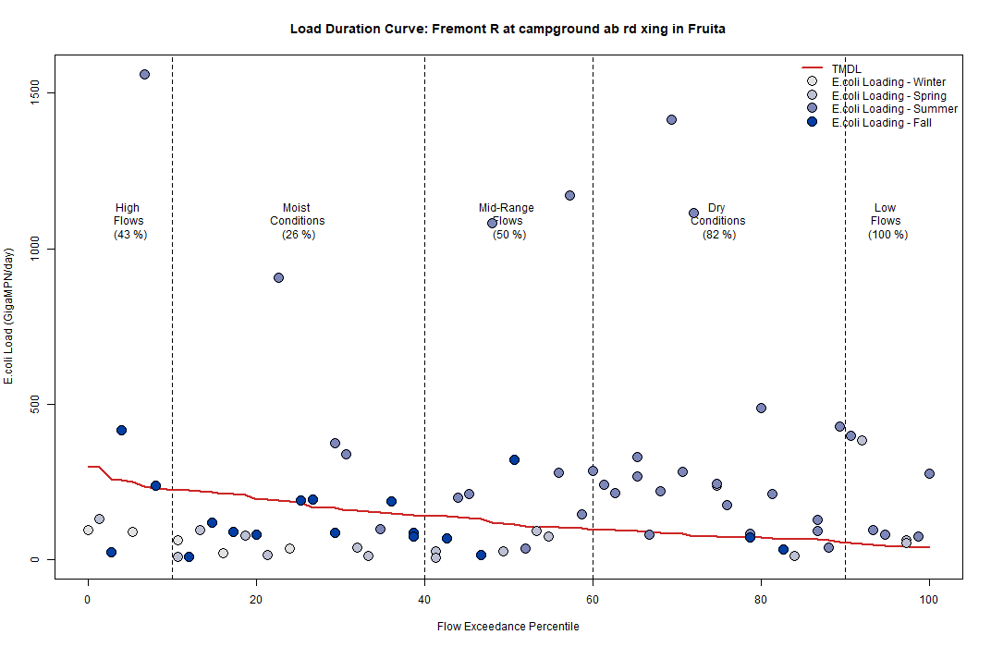

Figure 32. Calendar season load duration curve for 4954480: Fremont River at campground above road crossing in Fruita with data from 2010-2018
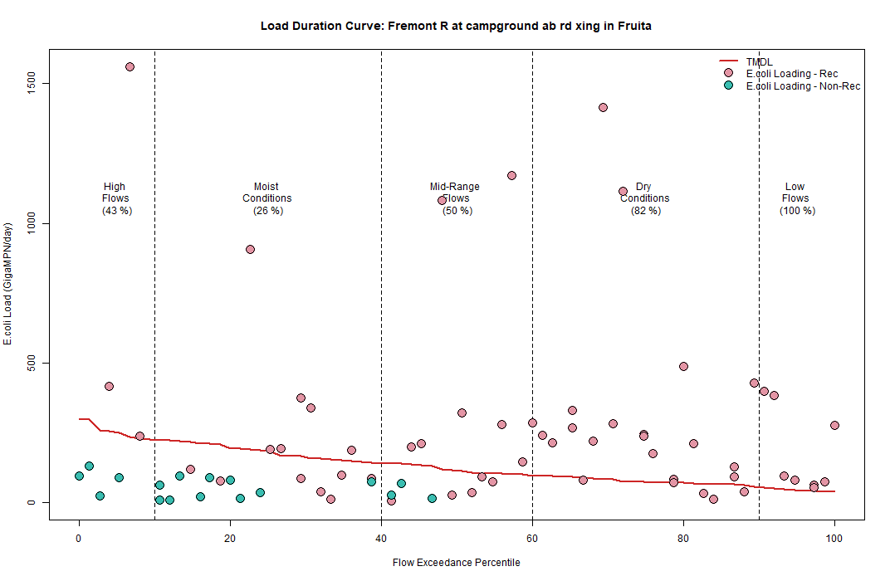

Figure 33. Recreation season load duration curve for 4954480: Fremont River at campground above road crossing in Fruita with data from 2010-2018

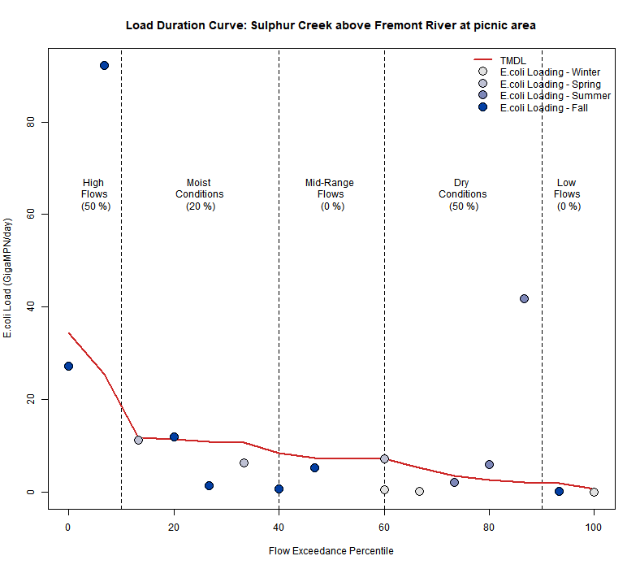

Figure 34. Calendar season load duration curve for 4954770: Sulphur Creek above Fremont River at picnic area with data from 2017-2018
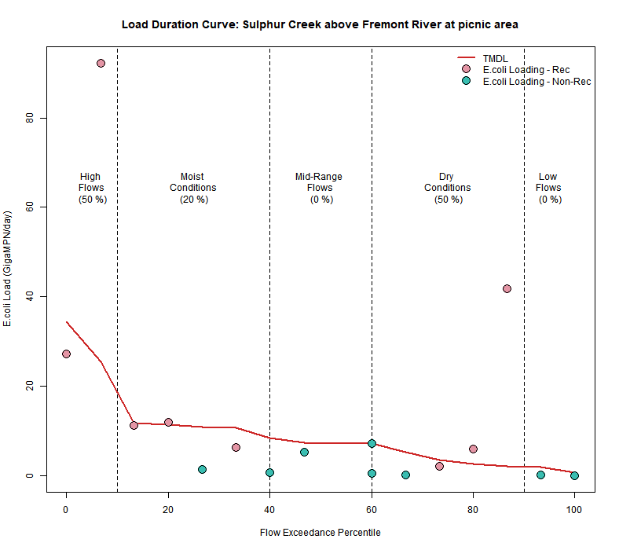

Figure 35. Recreation season load duration curve for 4954770: Sulphur Creek above Fremont River at picnic area with data from 2017-2018

5.3 TMDL Results
TMDL results were calculated using daily flow measurements and daily geometric means of E. coli concentrations. For each target site, the loading capacities and observed loadings of all recreation-season months were calculated. Then loading capacities and observed loadings of all recreation-season months that require a reduction were averaged to calculate the final percent reduction necessary. Monthly calculations are included in Tables 12 and 13. The geometric mean standard of 126 MPN/100mL was used for determination of the loading capacity.

5.4 Seasonality
Data for this TMDL were collected not only during the recreation season of May through October but also through the winter months to get a sense of the seasonality of exceedances.

The critical season for this E. coli TMDL is the recreation season. June, July and August are the months with the highest concentrations and greatest necessary percent reductions in loading for the target monitoring locations. Figures 36-39 show summaries of monthly observed E. coli concentrations for the target sites. These box plots show the range of concentrations, including the minimum, maximum, and median values observed.
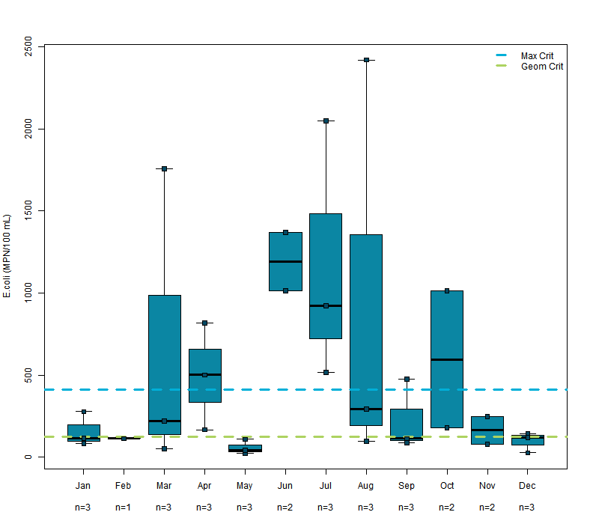

Figure 36. Monthly observed E. coli concentration summary for 4955330 Fremont River at Big Rocks Road from 2016-2018

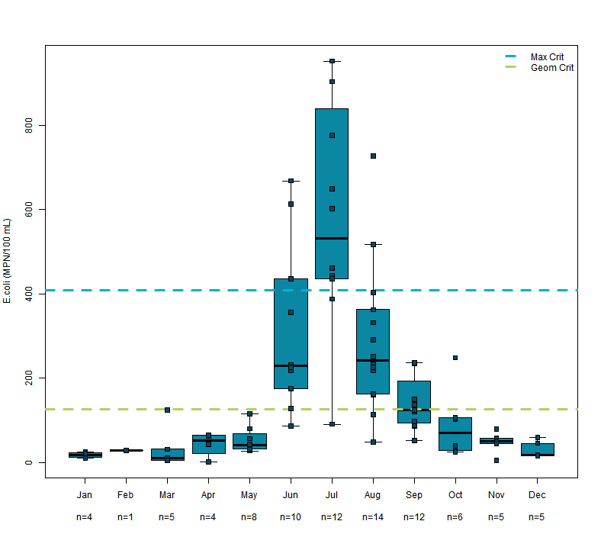

Figure 37. Image of 4954390: Fremont River at U12 Crossing from 2008-2018
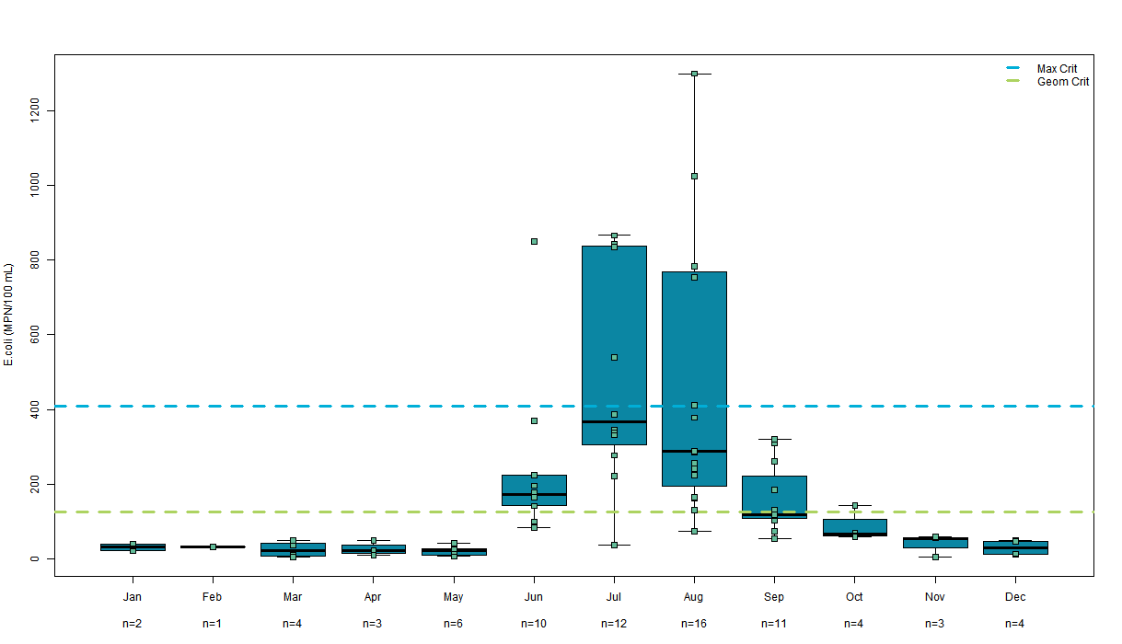

Figure 38. Monthly observed E. coli concentration summary for 4954480 Fremont River at Campground in CRNP from 2010-2018

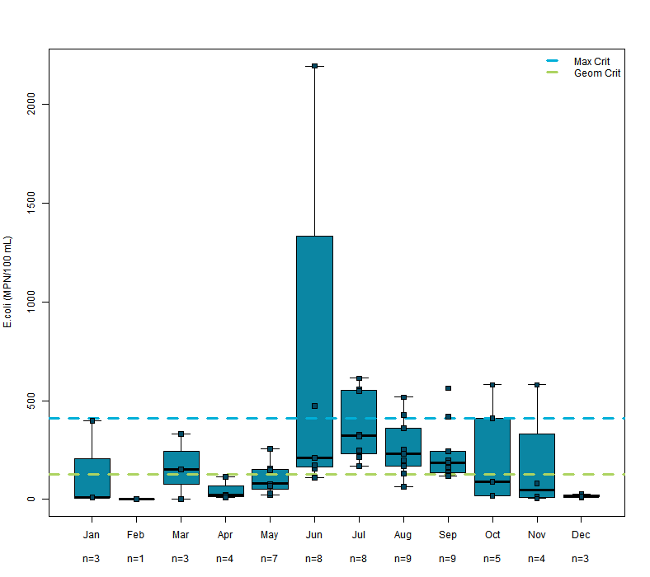

Figure 39. Monthly observed E. coli concentration summary for 4954770 Sulphur Creek above Fremont River at picnic area from 2012-2018

5.5 Margin of Safety
The margin of safety (MOS) refers to the required component of the TMDL that accounts for the uncertainty about the relationship between the pollutant loads and the quality of the receiving waterbody (CWA section 303(d)(1)(C)). The MOS can be implicit through use of conservative assumptions and values for calculations, or explicit as a certain percentage of the loading capacity. For the Fremont River TMDL, the MOS is explicitly included as 10% of the loading capacity. Implicit components include the use of the more conservative geometric mean standard of 126 MPN/100 mL for calculations, as well as averaging the recreation season months that required reductions to get the final TMDL calculations. Tables 12-15 show the E. coli TMDLs, including the observed loading, margin of safety, loading capacity, and the necessary percent reductions.

Table 12. Loading capacity, observed loading and necessary percent reductions based on 4955330 Fremont River at Big Rocks Road monitoring site data from 2016-2018

Month | Loading Capacity  (TMDL)  GigaMPN/day based on Geomean Std, minus 10% Margin of Safety | Observed Load  GigaMPN/day based on Geomean Std | Necessary Reduction
May (n=3) | 17.9 | 6.13 | 0%
June (n=2) | 10.7 | 128.7 | 92%
July (n=3) | 6.0 | 41.13 | 85%
Aug (n=3) | 14.3 | 278.8 | 95%
Sept (n=3) | 19.5 | 49.8 | 61%
Oct (n=2) | 26.5 | 131.5 | 80%

Table 13. Loading capacity, observed loading and necessary percent reductions based on 4954390 Fremont River at U12 Crossing monitoring site data from 2008-2018

Month | Loading Capacity  (TMDL)  GigaMPN/day based on Geomean Std, minus 10% Margin of Safety | Observed Load  GigaMPN/day based on Geomean Std | Necessary Reduction
May (n=8) | 149.6 | 65.7 | 0%
June (n=10) | 98.7 | 270.7 | 64%
July (n=12) | 96.9 | 533.5 | 82%
Aug (n=14) | 106.6 | 271.0 | 61%
Sept (n=12) | 139.8 | 523.7 | 73%
Oct (n=6) | 153.3 | 137.9 | 0%

Table 14. Loading capacity, observed loading and necessary percent reductions based on 4954480 Fremont River at campground in CRNP monitoring site data from 2018-2018

Month | Loading Capacity  (TMDL)  GigaMPN/day based on Geomean Std, minus 10% Margin of Safety | Observed Load  GigaMPN/day based on Geomean Std | Necessary Reduction
May (n=6) | 104.6 | 28.5 | 0%
June (n=10) | 78.3 | 148.8 | 47%
July (n=12) | 80.7 | 371.1 | 78%
Aug (n=16) | 102.9 | 497.0 | 79%
Sept (n=11) | 138.6 | 194.3 | 29%
Oct (n=4) | 168.6 | 120.2 | 0%

Table 15. Loading capacity, observed loading and necessary percent reductions based on 4954770 Sulphur Creek above Fremont River at picnic area monitoring site data from 2017-2018

Month | Loading Capacity (TMDL)  GigaMPN/day based on geomean std, minus 10% Margin of Safety | Observed Load  GigaMPN/day based on geomean std | Necessary Reduction
May (n=1 ) | 10.7 | 6.4 | 0%
June (n=2 ) | 5.1 | 21.7 | 76%
July (n=1 ) | 2.7 | 5.9 | 54%
Aug (n=1) | 3.6 | 2.1 | 0%
Sept (n=1) | 11.4 | 11.9 | 4%
Oct (n=2 ) | 29.7 | 50.1 | 41%

6.0 SOURCE ASSESSMENT
This section provides a summary of the sources of E. coli that contribute to the water-quality impairment in the Fremont River watershed. Typically, sources are characterized as either point or nonpoint sources. Point sources are spatially discrete and regulated under the Utah Pollution Discharge Elimination System (UPDES), and nonpoint sources are spatially distributed and not regulated. A summary of each source is provided below along with an estimate of the relative contribution of each.

6.1 Point Sources
A point source is defined by the CWA section 502(14) as “any discernible, confined and discrete conveyance, including any ditch, channel, tunnel, conduit, well, discrete fissure, container, rolling stock, concentrated animal feeding operation, or vessel or other floating craft, from which pollutants are or may be discharged. This term does not include agriculture stormwater discharges and return flow from irrigated agriculture.”

A point source may discharge effluent to a waterbody if the discharge is covered by a National Pollutant Discharge Elimination System (NPDES) permit. Effluent discharges are illegal when they violate the terms and conditions of an NPDES permit or if they are not covered by a NPDES permit. In Utah, EPA issues NPDES permits for point sources on federal property and tribal property. DWQ issues Utah Pollutant Discharge Elimination System (UPDES) permits for discharges from all other point sources.

DWQ issues two types of UPDES permits: individual and general. Individual permits are for discharges from a single entity and encompass a comprehensive permit application process. General permits cover a similar type of discharge across multiple entities. The general permits contain requirements for all permittees and are not specific to a single entity.

NPDES and UPDES permits are reissued every five years or when a permit must be modified to account for alterations to the point source. As NPDES/UPDES permits are reissued, they must be consistent with WLAs for point sources that are developed in the TMDL process. Both NPDES/UPDES permits and TMDLs protect waterbodies from receiving more pollutant loading than the waterbody can assimilate.

There are eight UPDES permits in the Fremont River watershed (Table 16). Two are included in the general permit for fish hatcheries throughout the state, but fish are cold blooded and therefore not expected to be a source of E. coli. Two are industrial stormwater permits that are issued to control runoff from industrial facilities. One is for water supply and irrigation, and three are included in the state general permit for pesticides. Pollutants most likely to be produced from these permitted activities include sediment, nutrients, and pesticides. Although all are located within the Fremont-2 and Fremont-3 AUs, none are likely to be sources of pathogen loading to the Fremont River watershed, so this source assessment will focus solely on nonpoint sources that include humans, wildlife, and livestock.
Table 16. UPDES permits in the Fremont River watershed

Permittee | UPDES Permit # | Activity
Utah Division of Wildlife Resources | UTG130003 | Fish Hatchery (Loa)
Utah Division of Wildlife Resources | UTG130007 | Fish Hatchery (Bicknell)
Capitol Reef National Park | UT0025798 | Water Supply and Irrigation
Wayne County | UTR000708 | Industrial Stormwater
Torrey Quarry | UTR275925 | Industrial Stormwater
Wayne County and Capitol Reef National Park | UTG170052  UTG170053  UTG170090 | General Permit Pesticides

6.2 Nonpoint Sources
Nonpoint source pollution comes from diffuse sources that do not originate from a single distinct point but is an accumulation of small sources of pollution throughout the watershed. Nonpoint source pollution enters waterbodies through surface water runoff, such as rainfall or snowmelt, or is deposited directly into streams. Potential contributors of nonpoint source E. coli pollution within the Fremont River watershed are humans, wildlife, and livestock.

To gain a better understanding of E. coli sources in the watershed, DWQ gathered and assessed information from the National Park Service, U.S. Forest Service, Bureau of Land Management, Utah Division of Wildlife Resources, School and Institutional Trust Lands Administration (SITLA), Central Utah Public Health Department, and local landowners. The intent of the assessment was to qualitatively evaluate potential sources so that financial and technical resources can be directed in the most efficient way possible to reduce their contribution.

6.2.1 Humans

Septic Systems
When properly designed and maintained, onsite wastewater treatment systems pose no significant threat to surface water quality. However, failing or improperly designed systems must be considered as a potential source of bacteria to waterways. The Central Utah Public Health Department (CUPHD) records show 1,287 individual septic systems in the portion of the Fremont River watershed where this study was conducted (email with Nathan Selin, CUPHD, 10/2/18). There are likely more systems than that, since the recordkeeping only began in the early 1980s. There are also several large underground wastewater disposal systems (LUWDS) in the area (email with Robert Beers, DWQ, 11/14/19). These systems are required to have an operating permit with the state that can be renewed every five years. One condition of the operating permit is an annual inspection performed by an onsite professional and submitted to DWQ. It is also likely there may be some unpermitted LUWDS that predate the permitting process. Those systems are shown in Tables 17 and 18.

The onsite wastewater treatment system in Capitol Reef National Park is subject to an annual inspection by the National Park Service regional public health officer as part of a survey of water and wastewater safety requirements. That system is also inspected every 3 years by the Utah State Engineer's Office as part of a sanitary survey of Park water and wastewater systems.

Table 17. Individual onsite wastewater treatment systems in the Fremont River TMDL area

Individual Onsite Septic Systems

Town | Number
Bicknell | 230
Fremont | 83
Grover | 53
Loa | 265
Lyman | 77
Teasdale | 180
Torrey | 382
Other | 17

Table 18. Large underground wastewater disposal systems in the Fremont River TMDL area

Large Underground Wastewater Disposal Systems

Town | Name | Average Flow  (gallons per day)
Loa | Brian Auto, Inc. | 660
Torrey | Capitol Reef Inn and Cafe | 5,000
Torrey | Capitol Reef Resort | >15,000
Torrey | Days Inn | 5,650
Torrey | Noor Hotel | 12,000
Torrey | Redridge Subdivision | 9,600

There is currently no map available for these septic systems. The state is working on compiling all septic system information into a database so mapping will be an option in the future.

Recreation
Capitol Reef National Park and the surrounding area is an internationally known tourist destination, with visitation numbers increasing annually. Many visitors are drawn to recreate in the water, especially during the summer months when temperatures are high. From 2009-2017, approximately 74-82% of the Park’s annual visitation occurred during the recreation season months of May through October (NPS 2018). Hiking in and adjacent to Park waters is very popular.

Capitol Reef National Park receives over a million visitors annually. It is likely that a very small percentage of those visitors are not properly disposing of human waste. While it is a challenge to quantify this behavior, improper disposal of waste does not appear to be problematic within Park boundaries, leading to the assumption that hikers are an unlikely source of significant pathogen loading to the Fremont River.

6.2.2 Wildlife
Wildlife are sources of E. coli loading in a watershed. The animal habitat and proximity to surface waters are principal factors that determine if animal waste can be transported to surface waters. Waterfowl and riparian mammals deposit waste directly into streams, while other riparian species deposit waste in the floodplain, which can be transported to surface waters by runoff from precipitation events. Animal waste deposited in upland areas can also be transported to streams and rivers; however, due to the distance from uplands to surface streams, only larger precipitation events can sustain sufficient amounts of runoff to transport upland animal waste to surface waters (Colorado DPHE, 2019).

The Fremont River watershed overlaps the Plateau Fish Lake Thousand Lakes Wildlife Management Unit (WMU) (Figure 40). The Utah Division of Wildlife Resources’ Richfield office (UDWR) provided population estimates for big game for the WMU (personal communication between Jim Lamb, UDWR, and Amy Dickey, DWQ, October 4, 2018). The Fremont River watershed accounts for approximately 29% of the WMU. UDWR estimates that there are 2,200 elk, 5,800 deer, 200 turkeys, and 1,000 pronghorn antelope within the Fremont-2 and Fremont-3 AUs.

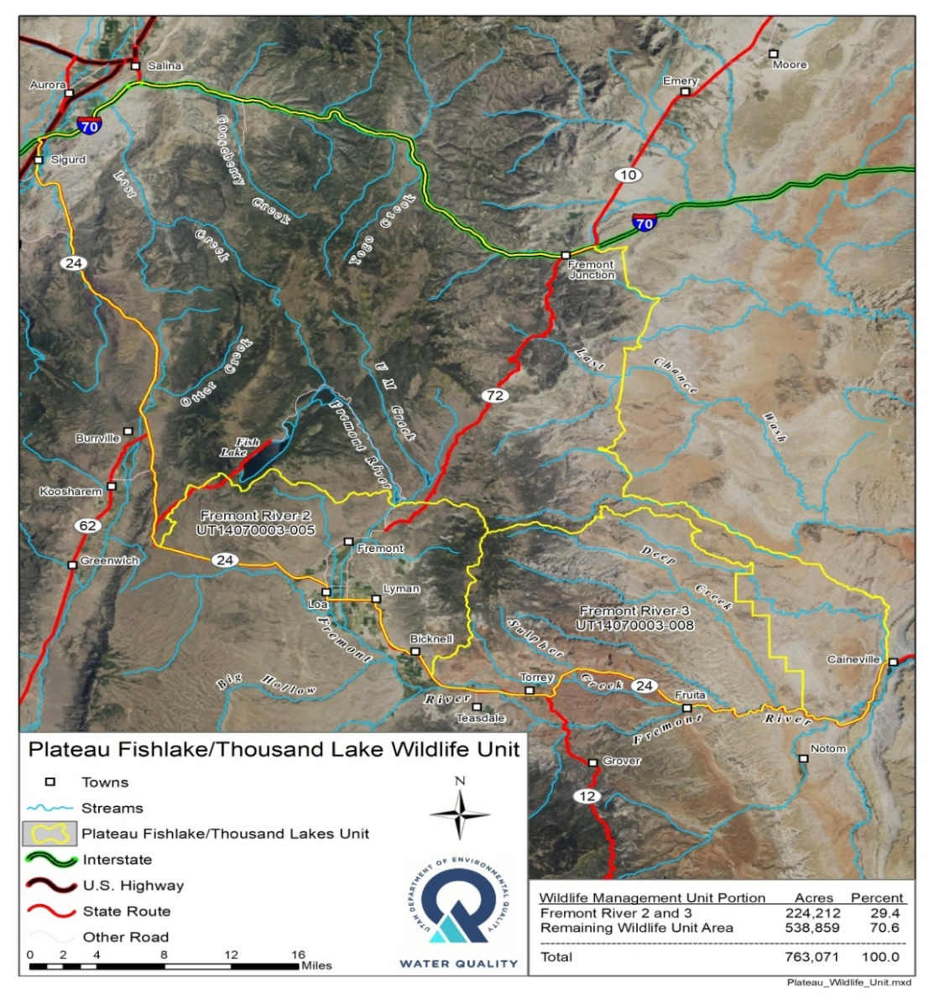
Figure 40. Utah Division of Wildlife Resources Plateau Fishlake/Thousand Lake Wildlife Management Unit

6.2.3 Livestock
Livestock grazing occurs on both private and federal land in the Fremont River watershed. In many cases, livestock are in close proximity to the river and have direct access to the river for stock watering. There are also instances of livestock grazing on pastures that are actively being irrigated with return flows entering the river.

Private Land
Landowners are not required to report the number of animals on their property, and the numbers vary from year to year depending on landowner choices. The upper watershed is not conducive to year-round grazing due to the snowpack and lack of accessibility. Estimates from the Utah Agriculture 2017 Census for Wayne County for the number of animals grazing private land are provided in Table 19. The majority of the watershed suitable for grazing and raising animals falls within the study area of Fremont-2 and Fremont-3, so the total number from the census was included for each animal type. Based on conversations with the Fremont River Conservation District, as well as with federal land grazing program staff, it was estimated that >95% of animals from private land spend part of the year on public grazing allotments. The public land estimates include those private animals so only 5% of the private land grazing estimates were used for the source assessment calculations.

Table 19. Livestock estimates on private property. (Source: 2017 Utah Agricultural Census)

Animal Type | Estimated number in watershed per season | Number used for TMDL source assessment calculations
Cows | 18,156 | 908 (5% of total)
Sheep | 7,575 | 379 (5% of total)
Horses | 50 | 50
Hogs | 60 | 60

Public Land
The US Forest Service, Bureau of Land Management (BLM) and SITLA all manage rangelands throughout Utah for multiple uses including wildlife habitat and livestock grazing. The rangelands are divided into allotments and pastures for management purposes. BLM Range Management staff provided the estimates shown below of livestock numbers during the recreation season for the allotments that are within the TMDL study area (Paul Caso, BLM Richfield Office). US Forest Service estimates were taken from the Fremont River Conservation District’s Fremont River Watershed Plan finalized in 2019 (NRCS, 2019). SITLA estimates were provided by the Resource Specialist for that region (Slate Stewart, SITLA Richfield) and can also be found on its online map of active grazing permits. Animals are grazed on public lands year-round but the source assessment calculations only consider those present during the recreation season when the E. coli standard applies. Tables and maps of allotment information and animal numbers for all three agencies can be found in Appendices B – D.

Table 20. Livestock estimates on public lands

Animal Type | Estimated number in watershed per recreation season
 | US Forest Service | Bureau of Land Management | SITLA
Cows | 2,493 | 1,094 | 536
Sheep | 1,063 | 2,692 | 57

6.3 Source Assessment Summary
An evaluation of E. coli loads by source was conducted using the bacteria production rate per animal and the number of animals in the watershed. The bacteria production rates presented below are based on research of fecal coliform bacteria, of which E. coli constitutes a large proportion. Fecal coliform levels have been shown to be well correlated with E. coli concentrations (Francy et al. 1993). It should also be noted that this assessment is specific to the impaired Fremont River AUs and does not include the high elevation headwaters or the portion of the watershed downstream of Capitol Reef National Park. The intent of this evaluation was to compare the different sources relative to each other and provide evidence of likely contributors to the impairment and help ensure that appropriate implementation measures can be taken. Several assumptions were used in this assessment, all of which are described below.

6.3.1 Bacteria Production
Bacteria production rates vary by animal, with cows and horses producing the largest loads and deer producing the lowest (Table 21) (Zeckoski et. al. 2005). In cases where literature estimates were not available (i.e., elk and bighorn sheep), estimates from livestock were used. For instance, the bacteria production rate for elk was assumed to be the same as a cow, and the production rate for bighorn sheep was assumed to be the same as domestic sheep, based on their similar weights.

Table 21. Bacteria production by animal
Animal¹ | Bacteria Production Rate (cfu²/animal/day)
Humans | 2.00 x 10⁹
Elk | 3.30 x 10¹⁰
Bighorn Sheep | 1.20 x 10¹⁰
Deer | 3.50 x 10⁸
Cows | 3.30 x 10¹⁰
Sheep | 1.20 x 10¹⁰
Horses | 4.20 x 10¹⁰
¹all literature values were taken from Zeckoski et. al. 2005
²cfu = colony forming unit. Note that CFU and MPN are similar measurements of bacterial concentration, byt they may vary slightly in values (Cho et al. 2010)

6.3.2 Source Assessment
Bacteria production rates from Table 21 were coupled with the number of animals in the watershed to identify the relative contribution of bacteria by source during the recreation season. The number of animals in the watershed per source was estimated based on available data. One hundred percent of the DWR estimates for wildlife in the study area were used. For livestock, the private grazing and public grazing numbers were summed to get a total number of cows, sheep, hogs and horses. For humans, the number of septic systems was used with an assumed household population of three (U.S. Census Bureau Website) and a system failure estimate of 50%. That number is based on the Bacteria Source Load Calculator Model (Zeckoski, 2005) which estimates that 20% of systems installed between 1966 and 1985 are failing, coupled with the knowledge that data is likely missing for some of the systems installed prior to 1985 throughout the watershed. Bacteria production was then summed by source to determine the relative contribution of humans versus livestock versus wildlife (Figure 41). According to this analysis, livestock contribute 74% of the E. coli loading compared to wildlife at 25% and humans at 1%.

Table 22. Bacteria contribution by source during the recreation season

Source | Bacterial Source | Fecal coliform production rate (cfu/animal/day) | Number in Fremont-2 and Fremont-3 AUs/rec season | Total bacteria production/rec season
Elk | Wildlife | 3.30 X 10¹⁰ | 2200 | 1.34 X 10¹⁶
Deer | Wildlife | 3.50 X 10⁸ | 5800 | 3.74 X 10¹⁴
Pronghorn Antelope | Wildlife | 3.50 X 10⁸ | 1000 | 6.44 X 10¹³
Turkeys | Wildlife | 9.30 X 10⁷ | 200 | 3.42 X 10¹²
Septic Systems | Human | 2.0 X 10⁹ | 1931 | 7.10 X 10¹⁴
Private Hogs | Livestock | 3.50 X 10⁸ | 60 | 3.86 X 10¹²
Private Horse | Livestock | 4.20 X 10¹⁰ | 50 | 3.86 X 10¹⁴
Private Cow | Livestock | 3.30 X 10¹⁰ | 908 | 5.51 X 10¹⁶
Private Sheep | Livestock | 1.20 X 10¹⁰ | 379 | 8.36 X 10¹⁴
Public Cow | Livestock | 3.30 X 10¹⁰ | 4123 | 2.91 X 10¹⁶
Public Sheep | Livestock | 1.20 X 10¹⁰ | 3812 | 8.42 X 10¹⁵

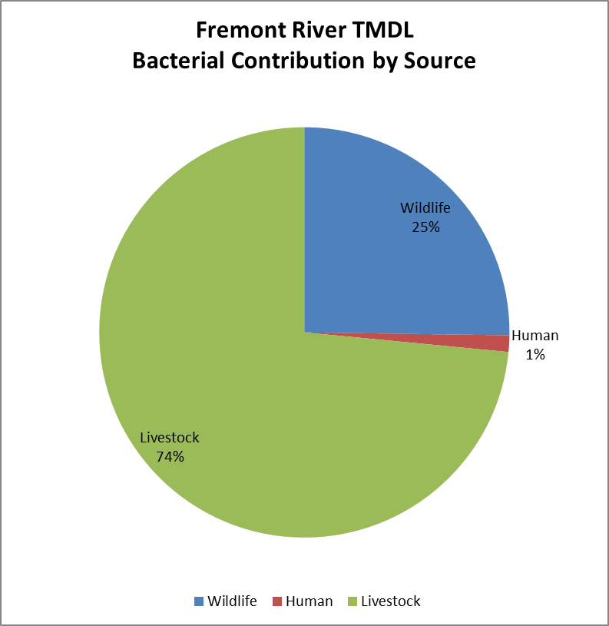

Figure 41. Estimated bacteria contribution by source during the recreation season

6.3.3 Assumptions and Uncertainty
Several assumptions were used in conducting this source assessment, and there are areas of uncertainty that are impossible to avoid in a study of this nature. For example, DWR wildlife estimates do not take into consideration the movement of animals in and out of the study area. This analysis also does not account for any wildlife species other than deer, elk, turkeys, and pronghorn antelope.

Private land grazing numbers for livestock were estimates, and vary from year to year dependent on producer choices.

For septic systems, it is likely that there are more systems in the watershed than recorded by the health department. However, not all septic systems are in proximity to a perennial waterway, which makes them less likely to contribute E. coli. A 50% failure rate was used for calculations.

For the human recreation source estimate, the assumption was made that humans were not likely to be defecating in or near the river, so no human recreation estimate was included in this source assessment.

Ideally this section would include a source assessment unique to each of the Fremont AUs since the sources are most likely different between the upper Fremont-2AU (predominately livestock) and the lower Fremont-3 AU (more potential for human and wildlife). Unfortunately it’s not feasible to increase the resolution on the source assessment with the data currently available.

6.3.4 Transport Pathways
The source assessment presented above was conducted assuming that bacteria are directly deposited into the river. In reality, it is much more likely that most defecation occurs on the landscape and the majority of the bacteria contained in the feces expire without ever reaching the waterway. A portion of the feces are transported to the river or to irrigation canals during overland flow events.

That is particularly true for livestock and wildlife that graze in flood-irrigated fields. Irrigation return flows are present in scattered locations throughout the Fremont-2 and Fremont-3 AUs. Water is diverted from rivers and canals at points along the pastures where it then runs through the grass. Any water in excess of what the soil can absorb becomes return flow that spills back into the river. If the water has come in contact with fresh fecal material, it is likely the return flows will be impacting water quality as a source of fecal pathogen loading. Due to the complexity of the irrigation network, DWQ has not conducted a comprehensive mapping exercise. Therefore, at this time, it is not possible to determine individual bacteria loads from each return flow.

7.0 IMPLEMENTATION PLAN
It will be necessary to implement Best Management Practices (BMP) to achieve TMDL endpoints. BMPs are practices used to protect and improve the physical, chemical, and biological integrity of surface and groundwater, primarily with regard to nonpoint sources of pollution. BMPs are most effective when combined to create a BMP system that comprehensively reduces or eliminates pollution from a single source. It should be noted that no single BMP system is considered to be the most effective way of controlling a particular pollutant in all situations; rather, the design of a BMP system should consider local conditions that are known to influence the production and delivery of nonpoint source pollutants.

The design of a BMP system should not only account for the type and source of pollutant, but should also consider background factors such as the physical, climatic, biological, social, and economic setting.
Implementing BMPs in the Fremont River Watershed to improve water quality has already proven to be effective. The Fremont River Conservation District, in cooperation with its partners, has implemented many projects in the watershed to improve water quality. Since 2002, over 2.5 miles of stream bank between the towns of Bicknell and Grover have been reshaped, stabilized, and re-vegetated. The District also worked with 17 different landowners in the watershed to relocate animal feeding operations from the riparian corridor or install BMPs that restrict runoff from leaving the feedlots. The Fremont River Conservation District has also played a large role in converting fields that were flood irrigated to more efficient sprinkler irrigation. The combination of these practices has resulted in a significant reduction in nutrient concentrations in the Fremont River, and river was removed from the 303(d) list of impaired waterbodies for excess phosphorous in 2014.

BMPs applied to the Fremont River watershed to reduce E. coli concentrations should include both structural and nonstructural techniques. Structural BMPs require a physical structure and could include projects such as installing vegetative buffer strips to filter out contaminants before they reach the stream, restricting livestock access to stream channels by installing fencing, and installing off-site watering systems or access points so livestock still have access to clean drinking water without spending a lot of time in and adjacent to the river. Repair or replacement of septic systems that are not functioning properly could reduce E. coli contamination from urban areas.

Development of grazing management plans is one nonstructural technique that could result in water quality improvement. While this practice is not considered structural, grazing management plans often require the installation of structures such as fencing and watering facilities to better manage livestock grazing.

Other practices that help address natural resource concerns outside of the scope of this study may be implemented in conjunction with the projects recommended in this plan to support the larger goal of improving the overall condition of the watershed.

7.1 Animal Feeding Operations
An animal feeding operation (AFO) is a feedlot or facility where animals are stabled or confined and fed or maintained for a total of 45 days or more in any 12-month period AND crops, vegetation, forage, or postharvest residues are not sustained in the normal growing season over any portion of the lot or facility (Utah R317-8-10). Historically, feedlots were constructed near rivers or streams so the animals could have access to water. However, feedlots located adjacent to waterways are likely to be a source of pathogen loading to those waterways. DWQ has made it a high priority to address all AFOs that have been identified as potential E. coli sources. Per state law (Utah Water Quality Act, Section 105.5), AFOs that discharge to the waters of the state are in violation of water quality regulations and may be subject to fines if action is not taken to eliminate runoff from the facility.

Feedlots that are adjacent to rivers, streams, or open canals should be relocated where feasible to another location where runoff from the feedlot will not reach the waters of the state. If this is not possible, proper BMPs should be installed to contain the runoff leaving the facility. These BMPs can consist of fences and offsite watering systems to restrict animal access to open ditches and streams. Berms should also be installed to catch any runoff leaving the facility.

There are several feedlots located in the Fremont River watershed. While some have been improved or relocated, there is a possibility that some are in need of additional repairs or maintenance. It would be beneficial to conduct an inventory of the feedlots in the watershed that have potential to discharge into the Fremont River. This inventory would help identify operations that may need additional assistance to come into compliance with state water quality standards. If operations are in need of improvements, the Fremont River Conservation District, along with DWQ and partner agencies, can provide technical and funding assistance to complete the work.

The cost to address AFOs can range from $1,000 to $150,000. Some AFOs can be fixed with the installation of a simple berm to prevent water from leaving the operation, while others may require that the feedlot be decommissioned and rebuilt in another location. Conservation planners can work with the landowners on a case-by-case basis to determine the most cost-effective approach while maintaining the functionality of the feedlot.

7.2 Grazing Management
Grazing management will require both structural and non-structural practices. Proper grazing management is a viable option in some areas of the watershed where landowners are able to distribute their cattle across a very large landscape. This may not be as effective in other areas where livestock are concentrated in smaller areas, such as sprinkler irrigated pastures. In some situations, it may be necessary to install fences along the creek to restrict livestock access to the riparian area. The protected area may still be grazed, but the animals will need to be removed when the riparian vegetation becomes stressed or overgrazed. This would also require installation of offsite watering troughs at access points to provide clean drinking water for livestock.

Installation of cross fencing is also a possible solution to help better distribute livestock across the landscape. Additional cross-fencing will allow landowners to better manage the feed within their pastures, allowing for increased rest periods. This can help improve plant health, thereby increasing the amount of feed available for livestock and reducing the amount of time the livestock spend in the riparian corridor.

Using aerial photography, DWQ estimated that approximately 15 miles of pasture adjacent to the Fremont River may be overgrazed and could potentially be contributing to the E. coli loading in the Fremont River. Follow up ground truthing on a site by site basis is recommended. While there are some grazing impacts in the tributaries, most appeared to be in good condition.

The types of practices that should be installed to help restrict livestock access to the river will be determined on a case-by-case basis. Conservation planners should work with the landowners to determine which practices will work better for their operations while also improving water quality.

The terms and conditions for grazing state and federal lands are included in the permits and leases issued, and contain habitat and vegetation goals. State and federal land grazing program managers are responsible for monitoring the condition of the allotments, responding as necessary to drought, fire and other resource conditions, and making improvements when necessary to minimize any potential impacts to natural resources including water quality.

7.3 Septic Systems
One of the potential sources of E. coli loading to the Fremont River are septic systems that were either improperly installed or are not being properly maintained. Septic systems that are properly planned, designed, sited, installed, operated, and maintained can provide excellent wastewater treatment. However, systems that are sited in densities that exceed the treatment capacity of regional soils, and systems that are poorly designed, installed, and operated, can cause water quality problems (EPA 2018).

The cost of annually maintaining a septic system can range from $250-$500, which is a fraction of the cost to replace an entire system. The average household septic system should be inspected at least every three years by a septic service professional. Household septic tanks are typically pumped every three to five years. Four major factors influence the frequency of septic pumping:
- Household size
- Total wastewater generated
- Volume of solids in wastewater
- Septic tank size

Since it can be challenging to know which households are properly maintaining their septic systems and which are not, one of the best ways to address this issue is to inform and educate the public about the impacts their septic tanks can have on public health and what they can do to better maintain them. One plan recommendation is to inventory and digitize septic systems to prioritize those most likely to be impacting water quality, as well as provide cost-sharing to homeowners who are willing to have their septic systems inspected or maintained, and assist with repairs or pumping if needed.

7.4 Information and Education Strategy
Only 5% of the Fremont River watershed is privately owned. However, many of the resource concerns that contribute to the E. coli impairment are found on private property. The Utah Nonpoint Source Information and Education Strategy developed in 2013 states that land owners and residents need to:
- Understand the importance of managing for clean water and the potential benefits proper management can have on their operations and other landscape-scale resources including soil, forage, animal health, and water availability on their lands.
- Understand and be trained in Best Management Practices (BMPs) that can be used to improve or protect water quality.
- Be aware of the various sources of funding and other technical assistance available to help in implementing best management practices.
- Be aware of changes in regulatory requirements.
- Understand local TMDLs and other watershed-based management approaches (Utah DWQ 2013).

One of the best ways to educate all interested stakeholders is to establish a local working group where all of the relevant topics impacting the watershed can be discussed. Topics addressed by this group can include potential BMPs for the watershed, local landowner input, reports on the current status of water quality in the watershed, and identification of the short-term and long-term goals of each member of the working group.

While some residents of the watershed may be aware of the water quality issues in their area, it is more likely that many are unaware that their practices could be contributing to water quality degradation. This plan recommends increased outreach to producers, including a dinner and presentation to discuss current water quality concerns and possible solutions.
Demonstration projects are very effective when helping landowners decide to implement BMPs on their property. This allows landowners to gain trust in the process and agency staff. It also gives other landowners the opportunity to see an example of successful BMPs and how they can improve their agricultural operations and water quality.

One of the best ways to address degraded water quality from improperly installed or maintained septic systems is to conduct an intensive information and educational campaign that presents the impacts septic systems may be having on water quality as well as ways homeowners can properly maintain those systems. DWQ recommends the development of an educational flier that can be distributed to Fremont River watershed stakeholders.

DWQ also recommends creation of an incentive program to help homeowners inspect and maintain their septic systems. In some instances, this incentive program could help pay for systems to be replaced if it is determined that the system is failing or is contributing to the E. coli loading in the watershed. This program should be developed by the local working group.

The Information and Education Strategy for the Fremont River consists of six main action items:
- Develop a local workgroup that helps inform local landowners, state and federal agencies, and environmental groups on pertinent issues within the watershed.
- Work with the Fremont River Conservation District to hold an education event with local landowners to inform them of the problems that exist, potential solutions, and entities that can provide technical and financial assistance.
- Implement demonstration projects that show local landowners the benefits of improved grazing management and relocation of feedlots away from the river.
- Develop an education campaign addressing the need for septic inspection and maintenance.
- Develop an incentive program to help landowners pay for the inspection and maintenance of their septic systems.
- Develop an education campaign addressing proper disposal of human waste on public lands in the watershed.
- Continue the Capitol Reef National Park Leave No Trace education program including the component on proper disposal of waste.

7.5 Implementation Cost and Technical Assistance
Implementation of nonpoint source projects is voluntary. The ability to correct the issues encountered will depend on the willingness of homeowners and producers to implement the recommended practices. A Project Implementation Plan will be developed that highlights the funding needs once individual projects and willing partners are identified. To fully fund all of the projects needed to achieve the required E. coli load reduction, it will be necessary to obtain funding from other partner agencies. Table 23 shows potential agencies that could contribute funding or resources to the implementation effort.

Table 23. Potential funding opportunities for nonpoint source projects

Entity | Grant program
Utah Division of Water Quality | Section 319 Grant Funding, Utah Nonpoint Source Pollution Grants
Natural Resource Conservation Service | Environmental Quality Incentives Program, National Water Quality Initiative Program
Utah Department of Agriculture and Food | Utah Conservation Commission Grants, Grazing Improvement Program Grants
Utah Department of Natural Resources | Watershed Restoration Initiative

Technical assistance will be needed in addition to funding for actual project implementation to ensure projects are properly planned and installed. This assistance can include soliciting grant funding, working with landowners to identify proper practices, obtaining proper permits, and writing reports highlighting the restoration activities. In general, much of this technical assistance will be provided by DWQ, NRCS, or UDAF employees, but in some instances, contractors may be required to develop designs or other critical planning components. The cost of this assistance should be calculated when determining the cost to implement this TMDL.

7.6 Implementation Schedule and Milestones
A schedule with milestones is a key element to any plan. These milestones should clearly identify activities and timelines to ensure transparency and help agencies plan ahead with funding proposals and reporting.

Table 24. Implementation schedule and milestones

Activity | Milestones | Agency Responsible | Timeline
Develop Local Watershed Group |  | UDWQ | 2020
Begin project monitoring | Sampling Analysis Plan developed in coordination with the Local Working Group | DWQ with assistance from USU Extension, UDAF, and CRNP | Ongoing through recreation seasons.  TBD for specific projects
Septic System Loading | Work with the local watershed group to develop an information and education strategy about the importance of septic inspections and maintenance. | DWQ, local watershed coordinator, or UDAF | Ongoing beginning in 2020
 | Obtain funding for septic outreach campaign |  | Submit NPS application  to DWQ Spring 2021
 | Implement septic outreach campaign with the goal of having at least 10 septic systems inspected and maintained annually |  | Ongoing beginning in 2020
 | Capitol Reef National Park septic system upgrade | CRNP | Planned for 2020
Feedlot Improvements | Identify landowners willing to relocate or make corrections to existing feedlots. | DWQ,UDAF, Local Conservation District | Ongoing beginning in 2020
 | Solicit funding for Phase 2 of the Fremont River Implementation Project | Local Conservation District | Submit NPS application to DWQ Spring 2021
 | Address runoff issues from feedlots in the Fremont River Watershed | DWQ, UDAF, Local Conservation District | Ongoing as funding is available
Grazing and Irrigation Water Management | Identify landowners (both public and private) willing to implement BMPs that will limit cattle access and improve grazing and/or flood irrigation practices along the Fremont River and tributaries | DWQ,UDAF, USFS, BLM, SITLA, Local Conservation District | Ongoing beginning in 2020
 | Solicit funding for Phase 3 of the Fremont River TMDL Implementation plan | Local Conservation District | Submit NPS application to DWQ Spring 2021
 | Reduce E. coli loading into the Fremont River and tributaries by installing grazing and irrigation related practices where necessary | DWQ, UDAF, USFS, BLM, SITLA, Local Conservation District | Ongoing as funding is available
Ongoing:  Evaluation of Watershed Plan/TMDL | All interested stakeholders |  | Every 5 years beginning in 2025

8.0 FUTURE MONITORING
Follow-up monitoring is required to ensure implementation efforts result in the attainment of water-quality standards. DWQ, in collaboration with other stakeholders, will continue to collect E. coli samples when and where appropriate to evaluate the effectiveness of pollution-control efforts.

E. coli monitoring will continue at established monitoring locations. Sites previously identified as impaired on the Utah 303(d) list will be monitored until full-support status is reached in order for the AU to be delisted for E. coli. Those sites include:
- 4954390: Fremont River at U12 Crossing
- 4954480: Fremont River at Campground in Fruita
After the 2018/2020 Integrated Report is released these sites will also include:
- 4955310: Spring Creek at U24 Crossing
- 4955330: Fremont River at Big Rocks Rd
Ideally, samples can be collected twice per month throughout the recreation season so results can be compared to the recreation season geo-mean standard, which requires 10 or more samples collected between May and October (See Appendix A for specific assessment scenarios). This effort will depend on available resources, specifically monitoring staff availability, for collecting samples at that increased frequency.

Many pathogen studies include a microbial source tracking (MST) component to determine through genetic analysis the sources of bacteria in the river. MST techniques can often help determine if the source is human, wildlife, or domestic animals. Microbial source tracking monitoring will be a priority in this watershed. Ideally, samples could be collected during multiple flow regimes including spring runoff, precipitation events, and base-flow conditions. MST analysis is expensive, so stakeholders will have to develop the most efficient strategy to collect this type of data.

9.0 PUBLIC INVOLVEMENT
Stakeholder participation for this TMDL process was achieved through meetings and site visits with state and federal agency representatives and local landowners.
Fremont River stakeholders include:
- Utah Division of Water Quality
- Utah Department of Agriculture and Food
- Fremont River Conservation District
- Capitol Reef National Park
- Utah State University Extension
- Bureau of Land Management
- US Forest Service
- Central Utah Health Department
- Natural Resources Conservation Service
- Private landowners

A TMDL kickoff meeting was held on August 29, 2018, at the Bicknell Community Center. DWQ water quality assessments and TMDL basics were discussed, as well as the specifics of the Fremont River E. coli impairment. The draft TMDL was presented virtually to stakeholders April 27, 2020 and emailed to them for their review and feedback.

Several site visits, monitoring runs, and watershed tours were conducted between 2017 and 2020 to help with development of this study. Some were with agency staff and others were with local landowners. An article discussing the kickoff meeting and TMDL process was posted in The Insider newspaper on September 6, 2018. This publication serves Wayne and Garfield counties.

Stakeholders were given the opportunity to provide feedback on the TMDL as part of the initial review process, as well as during rulemaking when the study is posted for a 30-day public review.

REFERENCES

Barcina, I. J.;Gonzalez, M.; Iriberri, J.; Egea L. (1990) Survival Strategies of
Escherichia coli and Enterococcus faecalis in Illuminated fresh and Marine
systems. J. Appl. Bacter. 68,189-198.

Benham, B.L.; Baffaut, C.; Zeckoski, R.W.; Mankin, K.R.; Pachepsky, Y.A.; Sadeghi, A.M.; Brannan, K.M.; Soupir, M.L.; Habersack, M.J. (2006) Modeling Bacteria Fate and Transport in Watersheds to Support TMDLs. Transactions of the ASABE. 49(4):987-1002.

Chronic, Halka. 1990. Roadside Geology of Utah. Mountain Press Publishing Company: Missoula, Montana.

Colorado Department of Public Health and Environment. March 13, 2019. Template for Developing a Total Maximum Daily Load Assessment in Colorado.

Easton, J. H.; Gauthier J. J.; Lalor, M.; Pitt, R. E. (2005) Die-off of Pathogenic E. coli in Sewage Contaminated Waters. AWRA Journal of the American Water Resources Association, 41, 1187-1193.

Environmental Protection Agency. 2012 Recreational Water Qulaity Criteria. https://www.epa.gov/sites/production/files/2015-10/documents/rwqc2012.pdf

Environmental Protection Agency. 2017 New Homebuyers Guide to Septic Systems
https://www.epa.gov/sites/production/files/2017-08/documents/170803-homebuyerssepticguide_508c.pdf

Environmental Protection Agency. 2018 Septic Systems Overview
https://www.epa.gov/septic/septic-systems-overview

Francy, D.S., D. Myers , and K.D. Metzker (1993) Escherichia coli and fecal-coliform bacteria as indicators of recreational water quality. Water-Resources Investigations Report 93-4083

Hackbarth, C., and R. Weissinger. 2018. Escherichia coli concentrations in Fremont River tributaries at Capitol Reef National Park, 2008–2017. Natural Resource Report NPS/NCPN/ NRR—2018/1698. National Park Service, Fort Collins, Colorado.

Jamieson, R. C.; Joy, D. M.; Lee, H.; Kostaschuk, R.; Gordon, R. J. (2004) Persistence of Enteric Bacteria in Alluvial Streams. J. Environ. Eng. Sci., 3, 203–212.

Kistemann, T.; ClaBen, T.; Koch, C.; Dangerndorf, F.; Fischeder, R.; Gebel, J.; Vacata V.; Exner, M. (2002) Microbial Load of Drinking Water Reservoir Tributaries during Extreme Rainfall and Runoff. Appl. Environ. Microbiology., 68, 2188-2197

Kolpin, et al. 2002. Pharmaceuticals, hormones, and other organic wastewater contaminants in U.S. streams, 1999-2000: a national reconnaissance. Environmental Science and Technology. 2002 March 15; 36(6): 1202-11.

Leclerc, H.; Mossel, D. A. A.; Edberg, S. C.; Struijk, C. B. (2001) Advances in the
Bacteriology of the Coliform Group: Their Suitability as Markers of Microbial
Water Safety. Annual Review of Microbiology, 55, 201-234.

Rose, J.B.; Sun, G.; Allen, C.P., and N.A. Sinclair. Microbial Quality and Persistence of Enteric Pathogens in Graywater from Various Household Sources. Journal of Water Resources, Volume 25, No 1. 1991.

U.S. Department of Agriculture. Natural Resources Conservation Service. 2019 Expanded Fremont River Watershed Coordinated Resource Management Plan. .

Utah Department of Environmental Quality, Division of Water Quality. Utah Bacteriological Monitoring Program: Bacteriological Standards. http://www.waterquality.utah.gov/Monitoring/Bac/methods.htm.
Utah Department of Environmental Quality, Division of Water Quality, 2013 Utah Nonpoint Source Pollution Management Plan, Appendix C, Utah Nonpoint Source Information and Education Strategy.

Utah Department of Environmental Quality (2016) Utah’s 2016 Integrated Report and 303(d) List of Impaired Waters. Department of Environmental Quality, Division of Water Quality, https://deq.utah.gov/ProgramsServices/programs/water/monitoring-reporting/assessment/docs/2016/chapter-3-river-and-stream-assessments-final2016ir-v2-1.pdf

Utah Division of Administrative Rules (2005) R317-2: Standards of Quality for Waters of the State. Utah State Bulletin, Vol. 2005, No. 1.

Utah Division of Administrative Rules (2005) R317-2: Standards of Quality for Waters of the State. Utah Administrative Code: Effective February 1, 2006. http:/./www.rules.utah.gov/publicat/code/r317/r317-002.htm#T15.

Utah Division of Wildlife Resources. 2017. Utah Big Game Annual Report. Publication No. 18-21.

World Health Organization (WHO). 2001. Water Quality: Guidelines, Standards and Health. Edited by Lorna Fewtrell and Jamie Bartram. Published by IWA Publishing, London, UK.

Zeckoski, R. W., Benham, B. L., Shah, S. B., Wolfe, M. L., Brannan, K. M., Al-Smadi, M., Dillaha, T. A., Mostaghimi, S., and C.D. Heatwole. 2005. BSLC: A Tool for Bacteria Source Characterization for Watershed Management. American Society of Agricultural Engineers ISSN 0883-8542. Vol. 21(5): 879-889.

Appendix A: Utah Division of Water Quality Listing Methodology for E. coli

Surface waters designated for 2A recreational use in Utah are assessed for E. coli using the water quality standards (Table 3) and the assessment methodology presented below.

The following rules provide an interpretation of Utah’s E. coli criteria based on the number of samples collected during the most recent six years of sampling. AUs that fail to meet any of these criteria will be included on Utah’s 303(d) list of impaired waters. However, exceptions may be made to these rules if a single collection event represents an outlier that biases results.

Scenario A: Seasonal assessment against maximum criterion
For each AU with ≥5 collection events in any recreation season, no more than 10% of samples collected from May 1st through October 30th may exceed 409 MPN/100 mL for 2A waters or 668 MPN/100 mL for 1C/2B waters throughout the most recent six years.
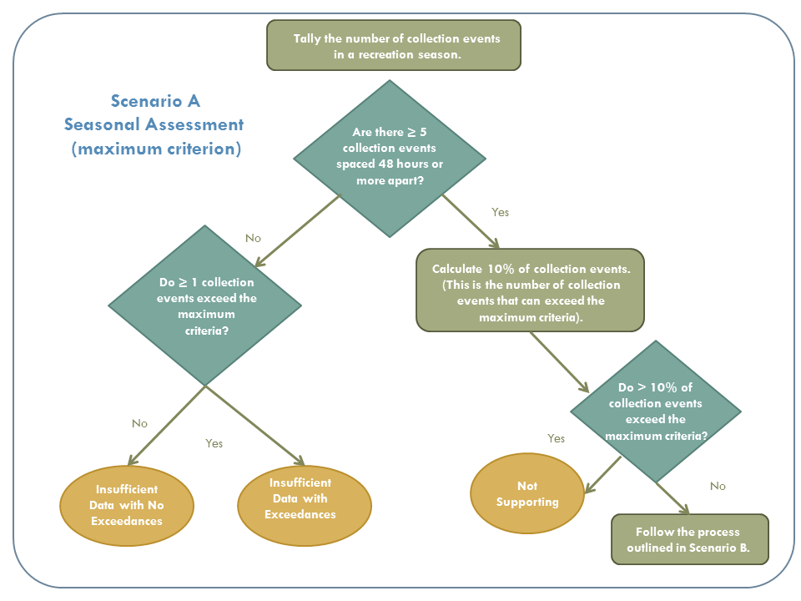
Figure 42. Seasonal assessment against maximum criterion
If less than 10 percent of collection events exceed the maximum criterion, the site is then assessed using the 30-day geometric mean criterion (Figure 4). There must be a minimum of five collection events in 30 days, with at least 48 hours between collection events, to assess against the 30-day geometric mean criterion directly. This ensures that collection events are adequately spaced and are representative of ambient conditions.

Scenario B: 30-day geometric mean assessment
For each AU with ≥5 collection events in any recreation season, no 30-day interval geometric means should exceed 126 MPN/100 mL for 2A waters or 206 MPN/100 mL for 1C/2B waters throughout the most recent six years.
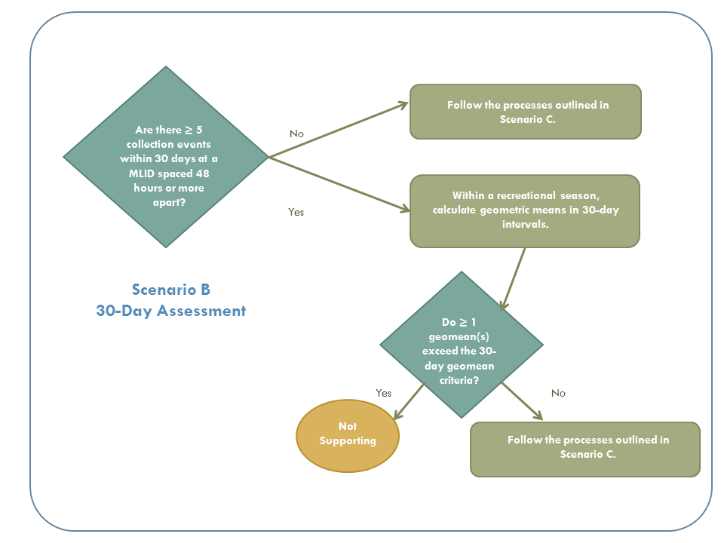
Figure 43. 30-day assessment against geometric mean

If adequate (at least five samples) and/or representative data spaced apart by at least 48 hours are not available to assess against the 30-day geometric mean, DWQ will assess E. coli data for the recreation season provided there are at least five collection events during the season (May - October). Exceedances of the geometric mean criterion will result in the site being classified either as impaired (minimum of 10 collection events in a recreation season) or as insufficient data (sample size is more than five but less than 10).

Scenario C: Seasonal geometric mean assessment
For each AU with ≥10 collection events in any recreation season, the geometric mean of all samples should not exceed 126 MPN/100 mL for 2A waters or 206 MPN/100 mL for 1C/2B waters throughout the most recent six years of recreation seasons.
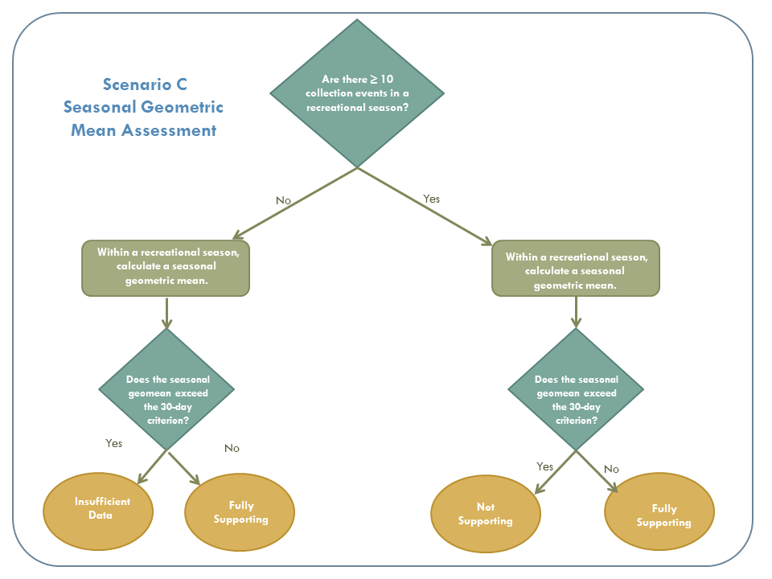
Figure 44. Seasonal geometric mean assessment

AUs with <5 samples in any recreation season will not be assessed for support of recreation uses. These sites will be prioritized for future sampling, particularly if limited data suggest a problem exists in the waterbody.

Sample collection and laboratory analysis are performed as prescribed in the approved DWQ protocols, which are consistent with EPA guidelines. All persons conducting sampling or analysis receive annual training by DWQ personnel. Replicates were collected for most of the Fremont River E. coli collection events. The geometric mean of samples is used to represent a single collection event for those results. Field blanks were also collected on each sampling run per DWQ monitoring protocol.

Assessment of Recreational and Drinking Water Uses
When determining the use attainment of a monitoring location with sampling results across multiple years, the following rules are applied in the following order.

Not Supporting (Category 5)
A waterbody is considered to be impaired (not meeting its designated beneficial uses) if any of the following conditions exist:
- A lake or reservoir with two or more posted health advisories or beach closures during any recreation season.
- Any monitoring location where E. coli concentrations from 10% or more of the collection events exceed the maximum criterion.
- Any monitoring location where the 30-day geometric mean exceeds the 30-day geometric mean criterion (minimum five collection events with at least 48 hours between collection events).
- Any monitoring location where the recreational season (May - October) geometric mean exceeds the 30-day geometric mean criterion (minimum of 10 collection events).

Insufficient Data or Information Assessment Considerations (Category 3A)
Sites with four or fewer samples in all seasons evaluated will be listed as not assessed, provided impairment is not suggested by a posted health advisory or beach closure. This applies to lakes and reservoirs only. All Category 3A sites will be prioritized for future monitoring, especially if limited data suggest impairment.

Fully Supporting (Category 1 or 2)
No evidence of impairment by any assessment approach for all recreation seasons over the most recent six years. A fully supporting determination can be made with a minimum of five collection events during the recreational season.

Appendix B: Bureau of Land Management Grazing Allotment Tables
(Information provided by Paul Caso, BLM Range Staff, email correspondence with DWQ on January 15, 2020)

Table 25: Bureau of Land Management grazing allotments in the Fremont River watershed
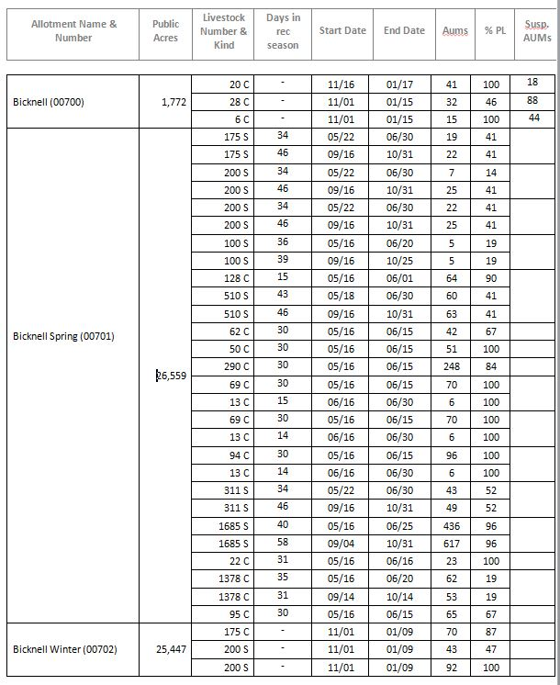

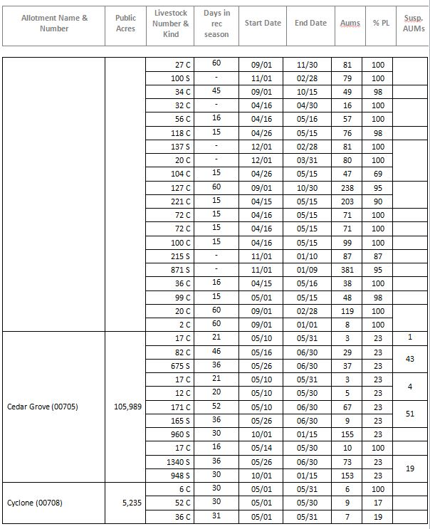

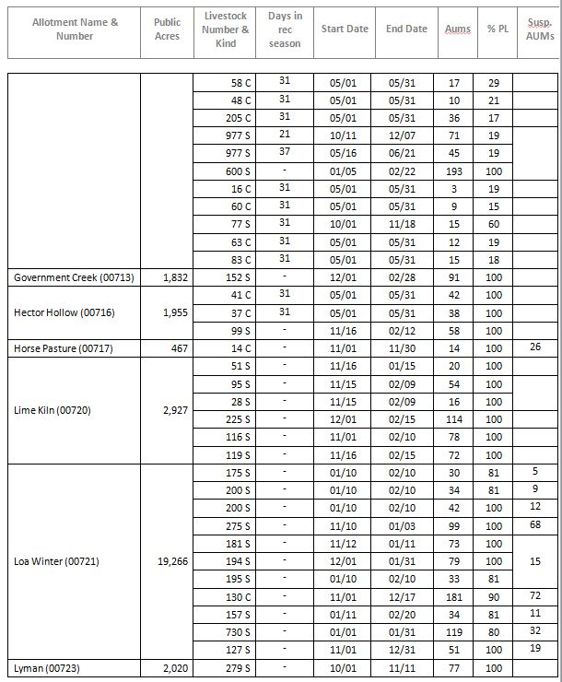

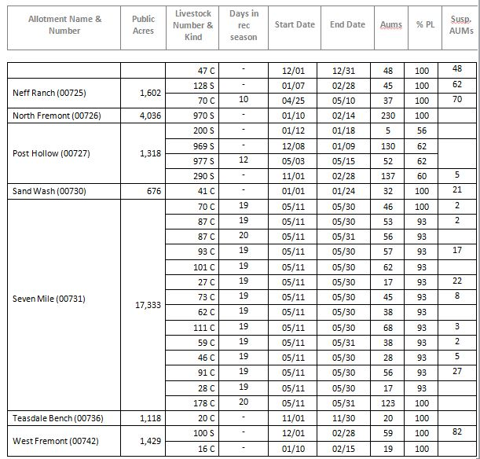

Figure 45. Map of BLM grazing allotments in the Fremont River watershed

Appendix C: SITLA Grazing Allotment Tables
(Information provided by Slate Stewart, Resource Specialist, email correspondence with DWQ on January 3, 2020)

Table 26: SITLA grazing allotments in the Fremont River watershed

Allotment Number | Acres | Total AUMs | Area | Season of Use | Animal Type
21198-E12 | 640 | 14 | Loa | 15 May - 15 Jun. | Cattle
21971-17 | 383 | 32 | Bicknell | 1 Oct. - 31 Jan. | Sheep
20420-00 | 67,093 | 6913 | Bicknell | 1 Jun. - 15 Oct. | Cattle
20608-10 | 3519 | 10 | Bicknell (41% Inside watershed) | 1 May - 31 May | Cattle
20608-10 | 3519 | 28 | West & East of Capital Reef | 1 Nov. - 31 May | Cattle
20608-A10 | 3519 | 10 | West & East of Capital Reef | 1 May - 31 May | Cattle
20608-A10 | 3519 | 28 | West & East of Capital Reef | 1 Nov. - 31 May | Cattle
20608-B10 | 3519 | 28 | West & East of Capital  Reef | 1 Nov. - 31 May | Cattle
20608-B10 | 3519 | 10 | West & East of Capital Reef | 1 May - 31 May | Cattle
21165-13 | 640 | 39 | Bicknell | 1 Nov. - 15 May | Sheep
21626-16 | 550 | 46 | Pine Creek | 15 Apr. - 15 May & 15 Oct. -15 Nov. | Cattle
22483-B11 | 2960 | 42 | Pine Creek | 1 Nov. - 1 Jan. | Sheep
22483-D11 | 2960 | 94 | Pine Creek | 15 Apr. - 15 Jun. | Cattle
22483-F12 | 3170 | 9 | Pine Creek | 16 Apr. - 15 May | Cattle
22483-G12 | 3170 | 10 | Pine Creek | 15 Apr. - 15 Jun. | Cattle
22535-10 | 480 | 15 | Teasdale | 1 Jan. - 31 Dec. | Cattle
22633-11 | 1312 | 30 | Teasdale | 21 Mar. - 21 Jun. | Sheep
22633-A11 | 1312 | 15 | Bicknell | 15 Jan. - 15 Feb. | Sheep
23000-11 | 1279 | 152 | Pine Creek | 1 Nov. - 31 May | Cattle
23295-13 | 120 | 11 | Teasdale | 1 Dec. - 15 May | Cattle

Appendix D: US Forest Service Grazing Allotments in Fremont River Watershed

Table 27: US Forest Service grazing allotments in the Fremont River watershed

Out of Study Area (Upper Watershed) | Allotment | Animal Numbers | AU | Season of Use | Percent in Watershed
 | Hancock | 1300 Sheep | 3975 | 07/15 to 10/15 | 61.3% Upper Fremont River
 | Daniels | 25 Cattle | 1694 | 07/01 to 09/30 | 4.3 % Upper Fremont River
 | Seven Mile | 1129 Cattle | 5193 | 06/01 to 10/16 | 100% Upper Fremont River
 | UM | 815 Cattle | 3749 | 06/01 to 10/16 | 99.7% Upper Fremont River
 | Tidwell | 670 Cattle | 3417 | 06/01 to 10/31 | 90.3% Upper Fremont River
 | Pin | 614 Cattle | 2906 | 06/01 to 10/20 | 0.9% Upper Fremont River
 | Solomon | 408 Cattle | 2081 | 06/01 to 10/31 | 31.2% Upper Fremont River
Within Study Area | Thousand Lake | 406 Cattle | 1854 | 06/01 to 10/15 | 90.6% with 1/3 in the Upper Fremont River
 | Dark Valley | 1107 Cattle | 4428 | 06/16 to 10/15 | 82.3% Upper Fremont River
 | North Slope | 275 Cattle | 1182 | 06/06 to 10/15 | 100% Lower Fremont River
 | Government Point | 1393 Sheep | 399 | 7/15 to 8/28 | 100% Lower Fremont River
 | Surveyor’s | 1412 Sheep | 424 | 7/16 to 09/01 | 83.4% Lower Fremont River
 | Donkey Meadows | 1387 Sheep | 416 | 07/19 to 09/03 | 55.4 % Lower Fremont River
 | Pleasant Creek | 614 Cattle | 2766 | 06/01 to 10/15 | 85.0% Lower Fremont River
 | Oak Creek | 1078 Cattle | 4856 | 06/01 to 10/15 | 45.7% Lower Fremont River

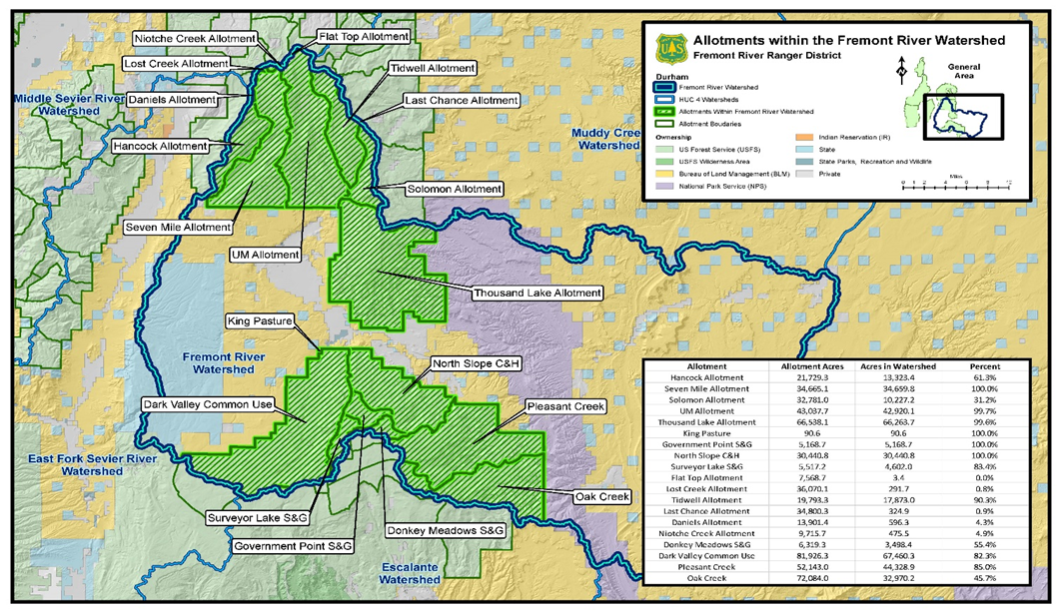
Figure 46. Map of current livestock grazing AUMs on Forest Service listed by allotment

Appendix E: U.S Fish and Wildlife Service List of Threatened and Endangered Species for Wayne County (Source: USFWS website, August 2019)

Table 28: U.S Fish and Wildlife Service list of threatened and endangered species for Wayne County, UT

Group | Name | Status | Recovery Plan
Birds | California condor (Gymnogyps californianus) | Experimental Population, Non-Essential*
 | Yellow-billed Cuckoo (Coccyzus americanus) | Threatened
 | Mexican spotted owl (Strix occidentalis lucida) | Threatened | Final Recovery Plan for the Mexican Spotted Owl, First Revision (Strix occidentalis lucida)
 | Southwestern willow flycatcher (Empidonax traillii extimus) | Endangered | Final Recovery Plan for the Southwestern Willow Flycatcher
Fish | Humpback chub (Gila cypha) | Endangered | Humpback Chub - 1990 2nd Revised Final Plan
 | Colorado pikeminnow (Ptychocheilus lucius) | Endangered | Colorado Pikeminnow (Ptychocheilus lucius) Recovery Plan (Amendment and Supplement for Recovery Goals)
 | Bonytail (Gila elegans) | Endangered | Bonytail Chub Revised Recovery Plan Goals
 | Razorback sucker (Xyrauchen texanus) | Endangered | Razorback Sucker - Recovery Goals
Flowering Plants | Maguire daisy (Erigeron maguirei) | Recovery | Maguire Daisy (Erigeron maguirei) Recovery Plan
 | Wright fishhook cactus (Sclerocactus wrightiae) | Endangered | Wright Fishhook Cactus
 | Last Chance townsendia (Townsendia aprica) | Threatened | Last Chance Townsendia
 | San Rafael cactus (Pediocactus despainii) | Endangered | Winkler cactus (Pediocactus winkleri) and San Rafael cactus (Pediocactus despainii)
 | Winkler cactus (Pediocactus winkleri) | Threatened | Winkler cactus (Pediocactus winkleri) and San Rafael cactus (Pediocactus despainii)
 | Barneby reed-mustard (Schoenocrambe barnebyi) | Endangered | Utah Reed-Mustards (3 spp.)
 | Ute ladies'-tresses (Spiranthes diluvialis) | Threatened | Ute Ladies'-Tresses Draft Recovery Plan
Mammals | Utah prairie dog (Cynomys parvidens) | Threatened | Utah Prairie Dog (Cynomys parvidens) Revised Recovery Plan

*On the basis of the best available information, the experimental population is not essential for the continued existence of the species.

Appendix F: Measured and modeled flow values used for loading calculations

Fremont River at Big Rocks Road
4955330
Date | Measured Ecoli | USGS Flow (cfs) | Modeled Flows (cfs) | Observed Flows (cfs)
1/26/2016 | 82.04 | 70.90 | 12.39 | No flow measured
3/30/2016 | 51.94 | 76.10 | 15.31 | No flow measured
4/29/2016 | 500.61 | 87.60 | 21.76 | No flow measured
5/30/2016 | 23.29 | 65.90 | 9.58 | No flow measured
6/30/2016 | 1367.08 | 62.40 | 7.62 | No flow measured
7/29/2016 | 517.13 | 55.60 | 3.80 | No flow measured
8/29/2016 | 290.93 | 66.00 | 9.64 | No flow measured
9/27/2016 | 474.12 | 67.40 | 10.42 | No flow measured
10/29/2016 | 178.21 | 67.20 | 10.31 | No flow measured
12/12/2016 | 26.21 | 74.00 | 14.13 | No flow measured
1/11/2017 | 276.89 | 80.30 | 17.66 | No flow measured
3/23/2017 | 1756.40 | 75.60 | 15.03 | No flow measured
4/27/2017 | 818.19 | 63.30 | 8.12 | No flow measured
5/25/2017 | 108.27 | 51.70 | 1.61 | No flow measured
7/19/2017 | 2047.64 | 49.80 | 0.55 | 0.922
8/30/2017 | 96.16 | 57.00 | 4.59 | No flow measured
9/13/2017 | 112.83 | 64.90 | 9.02 | No flow measured
11/7/2017 | 79.40 | 63.10 | 8.01 | No flow measured
12/11/2017 | 119.83 | 61.60 | 7.17 | No flow measured
1/4/2018 | 113.82 | 70.40 | 12.11 | No flow measured
2/7/2018 | 112.93 | 76.10 | 15.31 | 15.6
3/13/2018 | 219.03 | 74.10 | 14.18 | No flow measured
4/10/2018 | 166.59 | 71.20 | 12.56 | No flow measured
5/8/2018 | 43.31 | 63.30 | 8.12 | 4.39
6/7/2018 | 1012.78 | 48.10 | -0.41 | 1.315
7/11/2018 | 921.66 | 52.60 | 2.12 | 0.862
8/8/2018 | 2419.60 | 51.10 | 1.28 | 0.2186
9/20/2018 | 86.25 | 51.80 | 1.67 | No flow measured
10/17/2018 | 1012.78 | 64.50 | 8.80 | 8.6498
11/27/2018 | 248.09 | 63.60 | 8.29 | 12.1199
12/11/2018 | 144.02 | 71.30 | 12.61 | No flow measured

Fremont River at U12 Crossing
4954390
Date | Measured Ecoli | USGS Flow (cfs) | Modeled Flows (cfs) | Observed Flows (cfs)
8/22/2008 | 160.71 | 49.20 | 26.78 | No flow measured
10/11/2008 | 24.05 | 60.70 | 47.30 | No flow measured
11/18/2008 | 49.54 | 71.60 | 66.75 | No flow measured
1/17/2009 | 9.60 | 78.50 | 79.07 | No flow measured
3/13/2009 | 5.21 | 80.40 | 82.46 | No flow measured
4/11/2009 | 1.00 | 73.10 | 69.43 | No flow measured
5/2/2009 | 43.21 | 75.00 | 72.82 | No flow measured
7/14/2009 | 461.00 | 49.40 | 27.14 | No flow measured
8/15/2009 | 161.62 | 49.20 | 26.78 | No flow measured
9/21/2009 | 150.01 | 57.00 | 40.70 | No flow measured
10/10/2009 | 27.85 | 60.00 | 46.05 | No flow measured
11/5/2009 | 57.31 | 67.50 | 59.44 | No flow measured
12/10/2009 | 16.13 | 53.90 | 35.17 | No flow measured
5/14/2010 | 34.51 | 67.60 | 59.62 | No flow measured
6/13/2010 | 435.17 | 54.50 | 36.24 | No flow measured
7/7/2010 | 435.17 | 49.60 | 27.49 | No flow measured
7/15/2010 | 435.17 | 50.20 | 28.56 | No flow measured
7/26/2010 | 387.32 | 52.20 | 32.13 | No flow measured
8/2/2010 | 517.21 | 55.60 | 38.20 | No flow measured
8/11/2010 | 726.99 | 57.30 | 41.23 | No flow measured
8/23/2010 | 218.72 | 52.50 | 32.67 | No flow measured
8/31/2010 | 113.70 | 55.00 | 37.13 | No flow measured
9/9/2010 | 51.22 | 56.00 | 38.91 | No flow measured
9/13/2010 | 121.12 | 55.30 | 37.67 | No flow measured
9/21/2010 | 137.35 | 52.50 | 32.67 | No flow measured
10/22/2010 | 248.09 | 74.90 | 72.64 | No flow measured
11/18/2010 | 4.13 | 75.90 | 74.43 | No flow measured
12/10/2010 | 17.31 | 81.40 | 84.24 | No flow measured
3/11/2011 | 10.78 | 87.90 | 95.84 | No flow measured
6/23/2011 | 174.39 | 62.60 | 50.69 | No flow measured
7/14/2011 | 601.55 | 71.00 | 65.68 | No flow measured
7/29/2011 | 442.94 | 56.30 | 39.45 | No flow measured
8/11/2011 | 402.56 | 52.40 | 32.49 | No flow measured
8/30/2011 | 331.55 | 60.00 | 46.05 | No flow measured
9/20/2011 | 234.33 | 81.00 | 83.53 | No flow measured
5/18/2012 | 79.64 | 66.90 | 58.37 | No flow measured
6/12/2012 | 128.05 | 57.50 | 41.59 | No flow measured
Date | Measured Ecoli | USGS Flow (cfs) | Modeled Flows (cfs) | Observed Flows (cfs)
7/19/2012 | 90.54 | 58.00 | 42.48 | No flow measured
8/16/2012 | 250.71 | 67.20 | 58.90 | No flow measured
9/24/2012 | 124.81 | 70.00 | 63.90 | No flow measured
6/5/2013 | 225.73 | 48.10 | 24.82 | No flow measured
7/15/2013 | 903.30 | 53.20 | 33.92 | No flow measured
8/7/2013 | 362.30 | 56.10 | 39.09 | No flow measured
9/25/2013 | 2419.57 | 76.70 | 75.86 | No flow measured
5/5/2014 | 27.05 | 59.50 | 45.16 | No flow measured
6/6/2014 | 86.42 | 52.80 | 33.20 | No flow measured
7/15/2014 | 775.36 | 47.30 | 23.39 | No flow measured
8/11/2014 | 291.21 | 51.60 | 31.06 | No flow measured
9/17/2014 | 88.45 | 59.10 | 44.45 | No flow measured
5/5/2015 | 56.23 | 65.30 | 55.51 | No flow measured
6/1/2015 | 613.14 | 57.70 | 41.95 | No flow measured
6/29/2015 | 668.00 | 48.60 | 25.71 | No flow measured
9/10/2015 | 235.93 | 57.40 | 41.41 | No flow measured
1/26/2016 | 12.81 | 70.90 | 65.51 | No flow measured
3/30/2016 | 3.98 | 76.10 | 74.79 | No flow measured
4/29/2016 | 64.45 | 87.60 | 95.31 | No flow measured
5/30/2016 | 30.90 | 65.90 | 56.58 | No flow measured
6/30/2016 | 355.37 | 62.40 | 50.34 | No flow measured
7/29/2016 | 649.03 | 55.60 | 38.20 | No flow measured
8/29/2016 | 48.17 | 66.00 | 56.76 | No flow measured
9/27/2016 | 85.43 | 67.40 | 59.26 | No flow measured
10/29/2016 | 39.49 | 67.20 | 58.90 | No flow measured
12/12/2016 | 45.18 | 74.00 | 71.04 | No flow measured
1/11/2017 | 24.22 | 80.30 | 82.28 | No flow measured
3/23/2017 | 123.97 | 75.60 | 73.89 | No flow measured
4/27/2017 | 42.08 | 63.30 | 51.94 | 20.1
5/25/2017 | 115.67 | 51.70 | 31.24 | 25.8
6/21/2017 | 217.79 | 48.90 | 26.24 | 40.2
7/19/2017 | 952.11 | 49.80 | 27.85 | 44.8
8/30/2017 | 233.32 | 57.00 | 40.70 | No flow measured
9/13/2017 | 123.64 | 64.90 | 54.80 | No flow measured
10/12/2017 | 105.42 | 63.60 | 52.48 | 42.8
11/7/2017 | 78.45 | 63.10 | 51.59 | 70.4
12/11/2017 | 15.69 | 61.60 | 48.91 | 64.1
1/4/2018 | 21.32 | 70.40 | 64.61 | 74.3
2/7/2018 | 27.83 | 76.10 | 74.79 | 77.68
Date | Measured Ecoli | USGS Flow (cfs) | Modeled Flows (cfs) | Observed Flows (cfs)
3/13/2018 | 31.00 | 74.10 | 71.22 | 75.49
4/10/2018 | 63.16 | 71.20 | 66.04 | No flow measured
5/8/2018 | 37.09 | 63.30 | 51.94 | 28.28
6/7/2018 | 231.37 | 48.10 | 24.82 | 25.34
7/11/2018 | 1565.13 | 52.60 | 32.85 | 23.21
8/8/2018 | 225.77 | 51.10 | 30.17 | 22.94
9/20/2018 | 97.65 | 51.80 | 31.42 | 28.41
10/17/2018 | 102.00 | 64.50 | 54.08 | 39.5155
11/27/2018 | 45.11 | 63.60 | 52.48 | 70.0509
12/11/2018 | 58.85 | 71.30 | 66.22 | 71.3995

The Falls monitoring location (4954356) was once a very popular recreation and swimming spot in Capitol Reef National Park. Access was blocked in 2011 due to dangerous swimming conditions at this location and remains blocked today. The location is no longer monitored.

